All Saints’ Episcopal Church

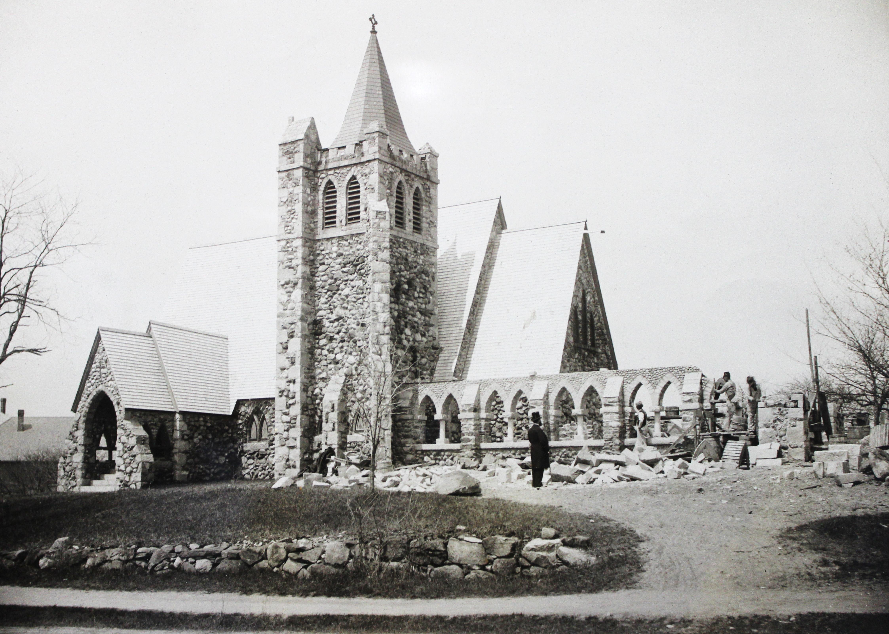

2016 Treasurer’s Report

ALL SAINTS’ PARISH ANNUAL MEETING
  - February 19, 2017

All Saints' Church
2016 Budget, Actual Revenues and Expenses; and 2017 Budget

REVENUES AND EXPENSES
 |  | SUMMARY
 |  |  | 2016 Budget | 2016 Actual | 2017 Proposed Budget
Total Revenues |  |  | 366,116 | 332,067 | 355,516
Total Expenses |  |  | 360,014 | 341,897 | 352,270
Net Total |  |  | 6,102 | -9,830 | 3,246
 |  | DETAILS
 |  |  | 2016 Budget | 2016 Actual | 2017 Proposed Budget
Revenues
Offering Income
Pledge Receipts |  |  | 302,000 | 280,226 | 290,000
Plate Receipts |  |  | 8,000 | 9,437 | 10,000
Flowers, Leaflets, Candles |  |  | 2,500 | 2,210 | 2,500
Thrift Shop |  |  | 3,000 | 3,000 | 3,000
Misc. Receipts and Gifts |  |  | 2,000 | 419 | 1,500
Endowment |  |  | 10,200 | 10,200 | 10,500
Housing DIT |  |  | 3,000 | 0 | 3,000
Special Projects |  |  | 10,400 | 8,039 | 10,000
Rental Income |  |  | 25,000 | 18,529 | 25,000
Interest Income |  |  | 16 | 6 | 16
Total Revenues |  |  | 366,116 | 332,067 | 355,516
Expenses
Personnel
Rector
Rector's Salary |  |  | 84,976 | 84,976 | 87,855
Rector's Housing |  |  | 11,000 | 11,000 | 11,000
Rector's Auto |  |  | 1,400 | 1,519 | 1,400
Rector's Medical Insurance |  |  | 15,500 | 15,995 | 16,000
Rector’s Sabbatical |  |  | 1,800 | 1,800 | 1,800
Rector's Continuing Ed. |  |  | 500 | 550 | 500
Rector's Pension |  |  | 17,276 | 17,276 | 18,250
Total Rector |  |  | 132,452 | 133,116 | 136,805
Staff
Staff Salaries
Parish Administrator/Financial Se |  |  | 35,350 | 31,630 | 26,000
Church School Administrator |  |  | 4,500 | 1,020 | 4,500
Music Director/Organist Salary |  |  | 30,000 | 30,000 | 30,900
Sexton Salary |  |  | 20,150 | 18,886 | 20,000
Social Security ER Tax |  |  | 5,050 | 4,992 | 5,101
Medicare ER Tax |  |  | 1,200 | 1,167 | 1,236
Staff Continuing Education |  |  | 800 | 530 | 0
Staff Pension Expense |  |  | 5,700 | 6,423 | 5,700
Staff Life Insurance |  |  | 225 | 218 | 225
Payroll Service Fees |  |  | 700 | 688 | 700
Total Staff |  |  | 103,675 | 95,554 | 94,362
Other Personnel Expenses
Worker's Comp Insurance |  |  | 1,200 | 1,655 | 1,400
Staff Travel Reimbursement |  |  | 0 | 31 | 0
Clergy Supply |  |  | 1,100 | 765 | 1,100
Organist Supply |  |  | 1,200 | 1,100 | 1,000
Admin. Supply |  |  | 1,750 | 1,927 | 200
Sexton Supply |  |  | 1,000 | 140 | 200
Total Personnel |  |  | 242,377 | 232,361 | 235,067
Administration
Office Expenses
General Office Supplies and Paper |  |  | 4,250 | 3,216 | 3,500
Copier Service Contract and Lease |  |  | 6,000 | 6,831 | 6,000
Technology - Internet and Computer |  |  | 3,800 | 3,600 | 3,800
Software Support Contract |  |  | 1,800 | 1,884 | 1,800
General Postage |  |  | 900 | 586 | 700
Total Administration |  |  | 16,750 | 16,117 | 15,800
Parish Life
Christian Formation
Adult Ed |  |  | 0 | 0 | 0
Vestry Retreat |  |  | 100 | 90 | 100
Church School |  |  | 4,000 | 7 | 4,000
Total Christian Formation |  |  | 4,100 | 97 | 4,100
Worship
Nursery Sitter |  |  |  |  | 2,400
Altar Guild
Altar Guild Expenses |  |  | 500 | 372 | 350
Sanctuary Candles |  |  | 350 | 315 | 200
Flowers |  |  | 1,500 | 1,087 | 1,300
Leaflets |  |  | 25 | 26 | 50
Music and Choirs
Music, books, supplies |  |  | 700 | 816 | 700
Instrumentalists |  |  | 400 | 600 | 400
Handbell Choir Expenses |  |  | 200 | 0 | 0
Instrument Maintenance & Repair |  |  | 2,600 | 2,282 | 2,300
Choir Robes |  |  | 250 |  | 0
Fellowship - Parish Life |  |  | 1,500 | 1,120 | 1,200
Stewardship Expenses |  |  | 200 | 340 | 375
Total Parish Life |  |  | 12,325 | 7,055 | 13,375
Community & Church
Diocesan Assessment |  |  | 37,949 | 37,949 | 38,078
Total Community & Church |  |  | 37,949 | 37,949 | 38,078
Buildings and Grounds
Mortgage Interest & Principal
Enterprise Loan Principal |  |  | 8,045 | 8,226 | 8,100
Enterprise Mortgage Interest |  |  | 4,200 | 4,019 | 4,200
Total Mortgage Interest & Principal |  |  | 12,245 | 12,245 | 12,300
Utilities
Electric |  |  | 8,000 | 7,904 | 7,750
Gas |  |  | 9,500 | 6,427 | 9,500
Water/Sewage |  |  | 1,725 | 2,320 | 1,750
Trash |  |  | 1,275 | 1,881 | 1,250
 |  |  | 20,500 | 18,532 | 20,250
Maintenance
Elevator Maintenance and Repair |  |  | 1,250 | 1,465 | 1,250
Security/Fire Alarm |  |  | 850 | 1,319 | 850
Maintenance Supplies |  |  | 2,168 | 2,154 | 2,350
General Repairs |  |  | 2,000 | 2,000 | 2,000
Snow Removal |  |  | 2,000 | 875 | 1,350
Liability Insurance |  |  | 9,600 | 9,825 | 9,600
Total Building & Grounds |  |  | 50,613 | 48,415 | 49,950
Total Expenses |  |  | 360,014 | 341,897 | 352,270
Net Total |  |  | 6,102 | -9,830 | 3,246

All Saints’ Church
Balance Sheet
December 2016

Assets
Current Assets
Checking Account
100010-01 - General Account |  |  |  |  | $25,153.28
100050-05 – All Saints Capital Campaign Fund |  |  |  |  | $124,289.79
Total Checking Account |  |  |  |  | $149,443.07
Petty Cash
100110-01 - Petty Cash |  |  |  |  | $200.00
Total Petty Cash |  |  |  |  | $200.00
Total Current Assets |  |  |  |  |  | $149,643.07
Investments
Diocesan Investment Trust
Endowment - Perm. Restricted
110210-02 - All Saints' Endowment |  |  |  |  | $220,627.49
110211-02 - Masonry Loan |  |  |  |  | ($4,300.70)
110321-02 - DIT Unrecognized Gain/Loss |  |  |  |  | $59,348.85
Total Endowment - Permanently Restricted |  |  |  |  | $275,675.64
DIT
110212-02 - Rector's Housing Fund |  |  |  |  | $88,435.15
110213-02 - Rector's Housing Unrecognized Gains/Loss |  |  |  |  | ($1,012.71)
110310-02 - DIT Music Fund |  |  |  |  | $10,250.54
110311-02 - Music Fund Unrecognized Gains/Loss |  |  |  |  | $1,262.91
Total DIT |  |  |  |  | $98,935.89
Total Diocesan Investment Trust |  |  |  |  | $374,611.53
Total Investments |  |  |  |  |  | $374,611.53
Fixed Assets
120510-01 - Furniture and Fixtures |  |  |  |  | $75,334.80
121010-01 - Machinery & Equipment |  |  |  |  | $22,044.01
122010-01 - Organ/Steinway |  |  |  |  | $245,594.28
123010-01 - Buildings |  |  |  |  | $1,195,000.00
124010-01 - Building Renovations |  |  |  |  | $928,722.24
125010-01 - Land |  |  |  |  | $200,100.00
Total Fixed Assets |  |  |  |  |  | $2,666,795.33
Total Assets |  |  |  |  |  | $3,191,049.93
Liabilities, Fund Principal, & Restricted Funds
Liabilities
Benefits Payable
230210-01 - Staff Pension Payable |  |  |  |  | $632.73
Total Benefits Payable |  |  |  |  |  | $632.73
Long Term Liabilities
240111-01 - Enterprise Bank Mortgage |  |  |  |  | $96,849.99
240112-01 - Accrued Rector's Sabbatical |  |  |  |  | $1,200.00
Total Long Term Liabilities |  |  |  |  |  | $98,049.99
Prepaid Pledges
250001-01 – Prepaid Pledges $4,825.00
Total Prepaid Pledges $4,825.00
Total Liabilities $103,507.72
Fund Principal
300000-01 – Fund Principal $2,969,385.28
Excess Cash Received ($71.27)
Total Fund Principal and Excess Cash Received $2,969,314.01

Restricted Funds
Total Temporarily Restricted $117,388.20
Total Permanently Restricted $840.00
Total Restricted Funds $118,228.20
Total Liabilities, Fund Principal & Restricted Funds $3,191,049.93

Living Stones Campaign Financial Report 2016

In late 2014, the vestry decided to put together a capital campaign to resolve some of the long-standing capital and financial issues of the parish. The intent was to raise money to address large repairs, capital improvements and debt retirement which the church had not been able to finance out of the annual budget. This five-year plan, named “Living Stones”, began in August 2015 and runs through calendar year 2021. A goal of $700,000 was decided upon and the Living Stones Capital Campaign began with the solicitation of our Vestry and key members of the Church. From the beginning, the campaign benefitted from the efforts of Rev. Bill Bradbury, Darlene Gossement, Melanie Hickcox, Maggie Marshall, Chris Mills, Trina Teele, and the consultant overseeing the entire operation, Erich Briggs of Butcher and Briggs. Church members were recruited to join the team and take charge of different aspects of the campaign. They are listed below:
The current status of the campaign is shown below
Committee Members:
Diane Olbert – Treasurer/Administrative Chair
Laura Marshall - Memorials Chair

Committee Members whose commitments were fulfilled in Fall 2016:

Mary Woodward and Dave Kuzara - Co-Chairs | Connie Pawelczak - Major Gifts Chair
Deb Forsberg - Spiritual Emphasis Chair | Valerie Cowart – Celebration Chair
Lissie Bates-Haus – Communications Chair
Cina Barker | Laura Barry
Linda Cahill | Darren Collins
Erik Forsberg | Lois Freeman
Al Graceffa | Karen Kowalski
Jean McCaffrey | Camille O’Brien
Edith Parekh | Adrienne Spear
Donald Van Dyne

Through hundreds of phone calls, emails and home visits, the congregation came together to participate in the Living Stones Campaign. There was talking! There was listening! And there was commitment to the Living Stone Campaign, to All Saints’ Church and its mission and to each other as fellow members in this parish. As a result, we can say that we are a church that is rich in good works, generous and ready to share.

On September 25, 2016, we held a celebration for the parishioners to signify the completion of our solicitation phase of the campaign. Since that time, we continue to receive pledges from our donors and provide financial data to our implementation committee.

Financial Information as of 12/31/2016:
Pledge goal: ​​ $700,000.00
Pledges to date: $545,595.00
Receipts to date: ​ $199,452.89
Expenses to date: $ 75,567.10

Diane Olbert, Treasurer/Administrative Chair

ALL SAINTS’ CHURCH THRIFT SHOP

2016 Financial Report

01/01/2016 Beginning Checking Balance | 9501.20
Receipts from Sales | 8006.68
Expenditures | (10182.61)
Ending Checking Balance | 7325.27
Set Aside 50% of Sales towards Consigners |  | 1830.00
Set aside as cushion & to avoid fees |  | 5000.00
Available Checking Balance |  | 495.27
2016 Expenditures
Consigners | 2641.31
Operating Supplies | 83.47 | Thrift Shop supplies
 | 40.00 | Cash for Fall opening day
 | 8.48 | Envelopes
 | 57.27 | Checks
 | 47.00 | Stamps
Maintenance | 489.32 | Rug installation
 | 932.37 | Rug
 | 76.00 | TS share of plumbing bill
 | 151.64 | Hooks and grab bar for renovation
Gifts - Out Reach | 25.00 | ASC Memorial Fund- Ann Kirk
 | 30.75 | ASC Endowment Fund- Barbara Lindberg
 |  | (gift plus consignor $)
 | 3000.00 | ASC General Fund
 | 500.00 | ASC Rector's Discretionary Fund
 | 1200.00 | ASC Feeding program
 | 800.00 | ASC for B-Safe
 | 100.00 | S.T.E.P. (Special Teams for Exceptional People)

Rector’s Discretionary Fund 2016
Opening Balance $2507.50
Deposits in 2016 $3450.00
Expenditures $4741.72

Closing Balance $1215.78

The Rector’s Discretionary Fund is an account created in accordance with the Canons of the National Church solely controlled by the Rector. It is funded by generous donations from the Thrift Shop, from honoraria for funerals, and gifts from individuals. The funds are used for people in need, both inside and outside the parish, outreach ministries, as well as scholarships for the Barbara C. Harris Summer Camp of the Diocese of Massachusetts. This has also been used to fund a nursery worker for Sunday mornings in hopes of creating an on-going nursery that would support our young families, many of whom are new to the parish. Please let me know if you have a need or would like to make a gift.
Respectfully Submitted,
The Reverend William J. Bradbury

