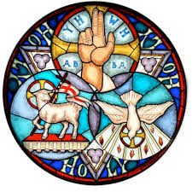

The First Sunday After Pentecost
Trinity Sunday
10:00 AM + June 7, 2020

Welcome! You are invited to participate fully in our worship.
Whoever you are, wherever you are on your journey of faith, welcome!

The Holy Eucharist: Rite Two
The Word of God

Hymn: Holy, Holy, Holy omit * vs Hymn 362 vs. 1, 3, 4
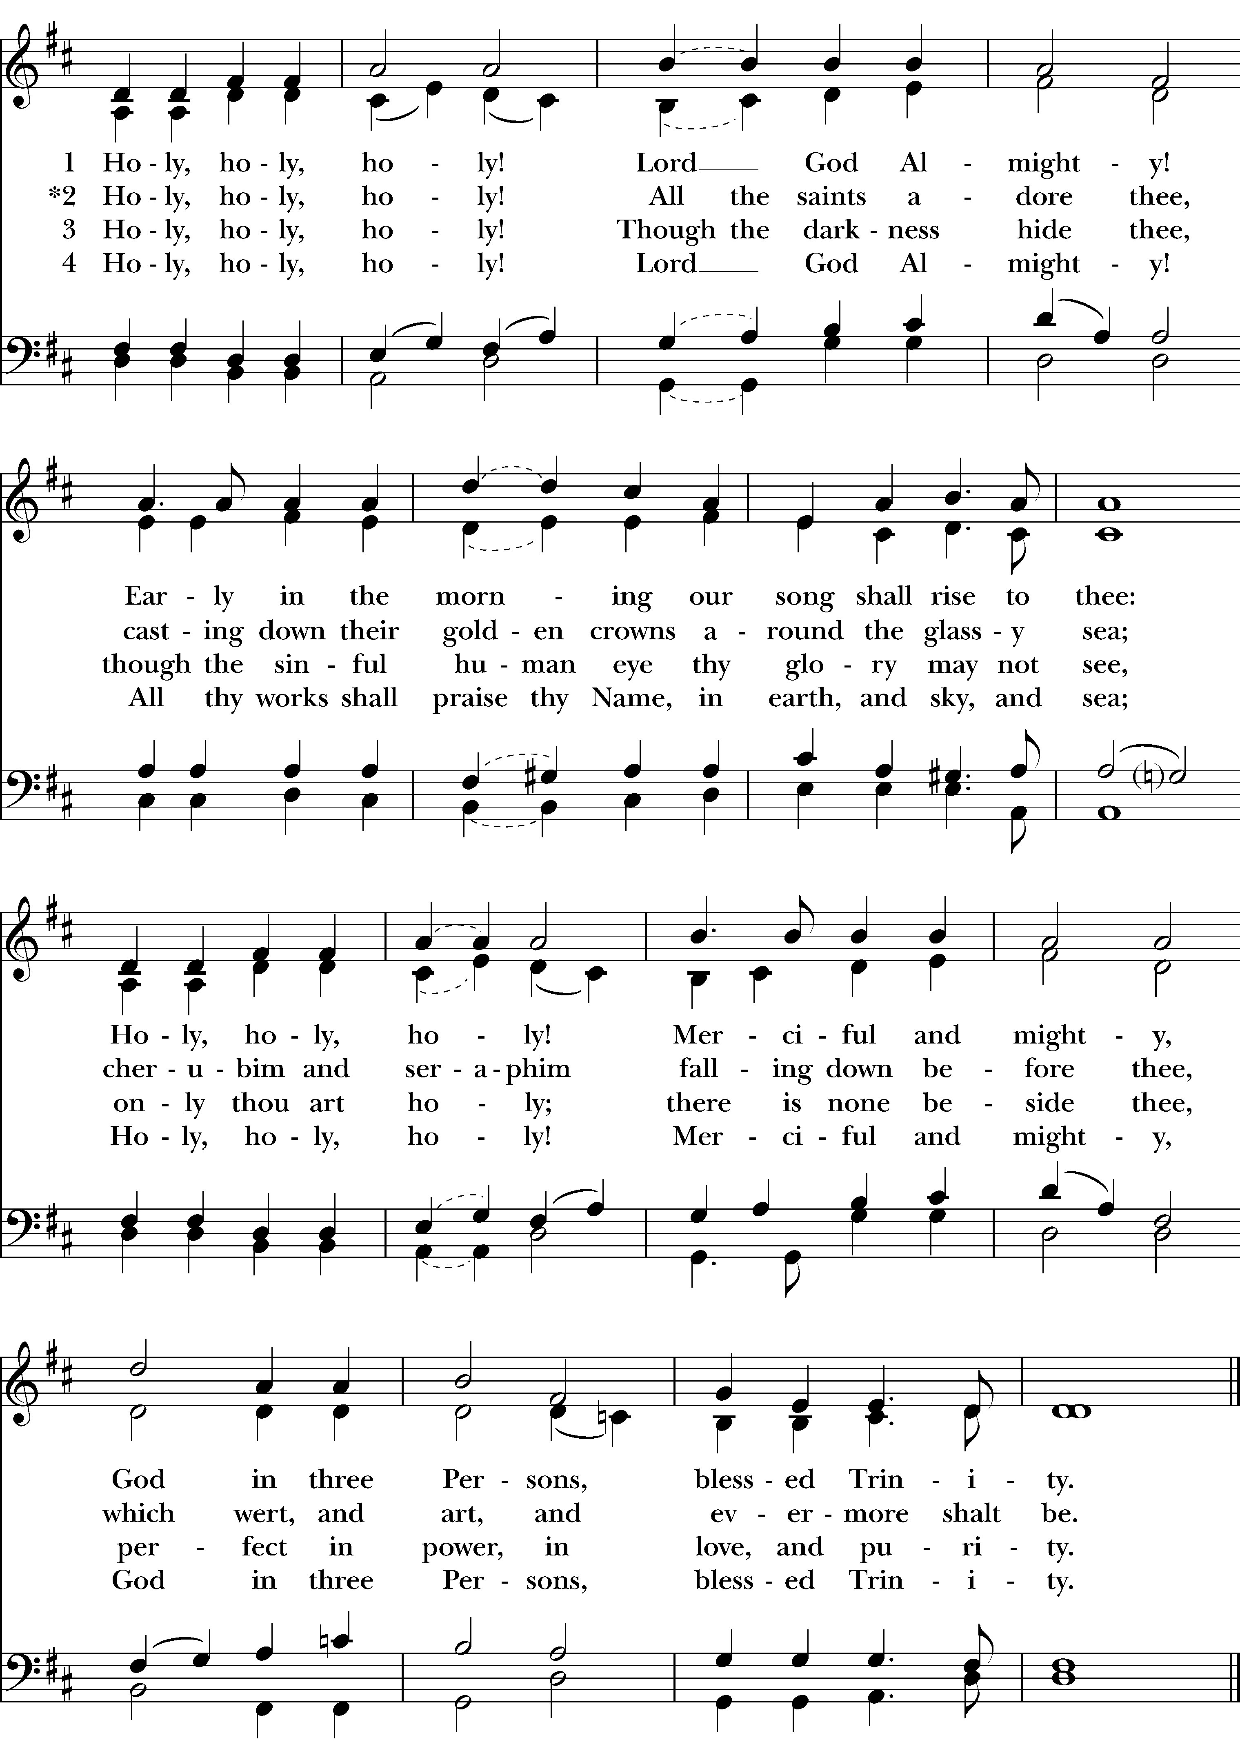
Celebrant Blessed be God: Father, Son, and Holy Spirit.
People And blessed be God’s kingdom, now and for ever. Amen.
Celebrant Collect for Purity
Almighty God, to you all hearts are open, all desires known, and from you no secrets are hid: Cleanse the thoughts of our hearts by the inspiration of your Holy Spirit, that we may perfectly love you, and worthily magnify your holy Name; through Christ our Lord.
Glory to God
Glory to God in the highest,
and peace to his people on earth.

Lord God, heavenly King,
almighty God and Father,
we worship you, we give you thanks,
we praise you for your glory.

Lord Jesus Christ, only Son of the Father,
Lord God, Lamb of God,
you take away the sin of the world;
have mercy on us;
you are seated at the right hand of the Father;
receive our prayer.

For you alone are the Holy One,
you alone are the Lord,
you alone are the Most High,
Jesus Christ,
with the Holy Spirit,
in the glory of God the Father. Amen.
Celebrant The Lord be with you.
People And also with you.
Let us pray together.
Collect Said in unison
Almighty and everlasting God, you have given to us your servants grace, by the confession of a true faith, to acknowledge the glory of the eternal Trinity, and in the power of your divine Majesty to worship the Unity: Keep us steadfast in this faith and worship, and bring us at last to see you in your one and eternal glory, O Father; who with the Son and the Holy Spirit live and reign, one God, for ever and ever. Amen.

A Reading from the Book of Genesis 1:1-2:4a
In the beginning when God created the heavens and the earth, the earth was a formless void and darkness covered the face of the deep, while a wind from God swept over the face of the waters. Then God said, “Let there be light”; and there was light. And God saw that the light was good; and God separated the light from the darkness. God called the light Day, and the darkness he called Night. And there was evening and there was morning, the first day.
And God said, “Let there be a dome in the midst of the waters, and let it separate the waters from the waters.” So God made the dome and separated the waters that were under the dome from the waters that were above the dome. And it was so. God called the dome Sky. And there was evening and there was morning, the second day.
And God said, “Let the waters under the sky be gathered together into one place, and let the dry land appear.” And it was so. God called the dry land Earth, and the waters that were gathered together he called Seas. And God saw that it was good. Then God said, “Let the earth put forth vegetation: plants yielding seed, and fruit trees of every kind on earth that bear fruit with the seed in it.” And it was so. The earth brought forth vegetation: plants yielding seed of every kind, and trees of every kind bearing fruit with the seed in it. And God saw that it was good. And there was evening and there was morning, the third day.
And God said, “Let there be lights in the dome of the sky to separate the day from the night; and let them be for signs and for seasons and for days and years, and let them be lights in the dome of the sky to give light upon the earth.” And it was so. God made the two great lights—the greater light to rule the day and the lesser light to rule the night—and the stars. God set them in the dome of the sky to give light upon the earth, to rule over the day and over the night, and to separate the light from the darkness. And God saw that it was good. And there was evening and there was morning, the fourth day.
And God said, “Let the waters bring forth swarms of living creatures, and let birds fly above the earth across the dome of the sky.” So God created the great sea monsters and every living creature that moves, of every kind, with which the waters swarm, and every winged bird of every kind. And God saw that it was good. God blessed them, saying, “Be fruitful and multiply and fill the waters in the seas, and let birds multiply on the earth.” And there was evening and there was morning, the fifth day.
And God said, “Let the earth bring forth living creatures of every kind: cattle and creeping things and wild animals of the earth of every kind.” And it was so. God made the wild animals of the earth of every kind, and the cattle of every kind, and everything that creeps upon the ground of every kind. And God saw that it was good.
Then God said, “Let us make humankind in our image, according to our likeness; and let them have dominion over the fish of the sea, and over the birds of the air, and over the cattle, and over all the wild animals of the earth, and over every creeping thing that creeps upon the earth.”
So God created humankind in his image, in the image of God he created them; male and female he created them.
God blessed them, and God said to them, “Be fruitful and multiply, and fill the earth and subdue it; and have dominion over the fish of the sea and over the birds of the air and over every living thing that moves upon the earth.” God said, “See, I have given you every plant yielding seed that is upon the face of all the earth, and every tree with seed in its fruit; you shall have them for food. And to every beast of the earth, and to every bird of the air, and to everything that creeps on the earth, everything that has the breath of life, I have given every green plant for food.” And it was so. God saw everything that he had made, and indeed, it was very good. And there was evening and there was morning, the sixth day.
Thus the heavens and the earth were finished, and all their multitude. And on the seventh day God finished the work that he had done, and he rested on the seventh day from all the work that he had done. So God blessed the seventh day and hallowed it, because on it God rested from all the work that he had done in creation.
These are the generations of the heavens and the earth when they were created.
People’s response after the reading Thanks be to God.

Psalm 8
1 O Lord our Governor, *
how exalted is your Name in all the world!
2 Out of the mouths of infants and children *
your majesty is praised above the heavens.
3 You have set up a stronghold against your adversaries, *
to quell the enemy and the avenger.
4 When I consider your heavens, the work of your fingers, *
the moon and the stars you have set in their courses,
5 What is man that you should be mindful of him? *
the son of man that you should seek him out?
6 You have made him but little lower than the angels; *
you adorn him with glory and honor;
7 You give him mastery over the works of your hands; *
you put all things under his feet:
8 All sheep and oxen, *
even the wild beasts of the field,
9 The birds of the air, the fish of the sea, *
and whatsoever walks in the paths of the sea.
10 O Lord our Governor, *
how exalted is your Name in all the world!

A Reading from Paul’s 2nd Letter to the Corinthians 13:11-13
Finally, brothers and sisters, farewell. Put things in order, listen to my appeal, agree with one another, live in peace; and the God of love and peace will be with you. Greet one another with a holy kiss. All the saints greet you.
The grace of the Lord Jesus Christ, the love of God, and the communion of the Holy Spirit be with all of you.
People’s response after the reading Thanks be to God.

The Holy Gospel according to Matthew 28:16-20
People Said before the reading Said after the reading
Glory to you, Lord Christ. Praise to you, Lord Christ.
The eleven disciples went to Galilee, to the mountain to which Jesus had directed them. When they saw him, they worshiped him; but some doubted. And Jesus came and said to them, “All authority in heaven and on earth has been given to me. Go therefore and make disciples of all nations, baptizing them in the name of the Father and of the Son and of the Holy Spirit, and teaching them to obey everything that I have commanded you. And remember, I am with you always, to the end of the age.”

The Sermon The Reverend Dr. Paul Kolbet

Silent Meditation

The Nicene Creed Spoken by all, standing.
We believe in one God, the Father, the Almighty,
maker of heaven and earth, of all that is, seen and unseen.
We believe in one Lord, Jesus Christ, the only Son of God, eternally begotten of the Father, God from God, Light from Light, true God from true God, begotten, not made, of one Being with the Father. Through him all things were made.
For us and for our salvation he came down from heaven; by the power of the Holy Spirit he became incarnate from the Virgin Mary, and was made man. For our sake he was crucified under Pontius Pilate; he suffered death and was buried.
On the third day he rose again in accordance with the Scriptures; he ascended into heaven and is seated at the right hand of the Father.
He will come again in glory to judge the living and the dead, and his kingdom will have no end.
We believe in the Holy Spirit, the Lord, the giver of life, Who proceeds from the Father and the Son.
With the Father and the Son he is worshiped and glorified.
He has spoken through the Prophets.
We believe in one holy catholic and apostolic Church.
We acknowledge one baptism for the forgiveness of sins,
We look for the resurrection of the dead, and the life of the world to come. Amen.

The Prayers of the People – Form V
In peace, let us pray to the Lord, for the holy Church of God, that it may be filled with truth
and love, and be found without fault at the day of your coming, we pray to you, O Lord.

For Michael our Presiding Bishop, for Alan and Gale our Bishops, for all bishops and other ministers, and for all the holy people of God, we pray to you, O Lord.

For all who fear God and believe in you, Lord Christ, that our divisions may cease, and that all may be one as you and the Father are one, we pray to you, O Lord.

For the mission of the Church, that in faithful witness it may preach the Gospel to the ends of the earth, we pray to you, O Lord.

For those who do not yet believe, and for those who have lost their faith, that they may receive the light of the Gospel, we pray to you, O Lord.

For the peace of the world, that a spirit of respect and forbearance may grow among nations and peoples, we pray to you, O Lord.

For those in positions of public trust [especially Donald our President and Charlie our Governor], that they may serve justice, and promote the dignity and freedom of every person, we pray to you, O Lord.

For a blessing upon all human labor, and for the right use of the riches of creation, that the world may be freed from poverty, famine, and disaster, we pray to you, O Lord.

For the poor, the persecuted, the sick, and all who suffer; for refugees, prisoners, and all who are in danger; that they may be relieved and protected, we pray to you, O Lord.

For this congregation, that we may be delivered from hardness of heart, and show forth your glory in all that we do, we pray to you, O Lord.

For ourselves; for the forgiveness of our sins, and for the grace of the Holy Spirit to amend our lives, we pray to you, O Lord.

For all who have commended themselves to our prayers; for our families, friends, and neighbors; that being freed from anxiety, they may live in joy, peace, and health, we pray to you, O Lord.

For ________________, we pray to you, O Lord.

For all who have died in the communion of your Church, and those whose faith is known to you alone, that, with all the saints, they may have rest in that place where there is no pain or grief, but life eternal, we pray to you, O Lord.

Rejoicing in the fellowship of all the saints, let us commend ourselves, and one another, and all our life to Christ our God.

PRAY FOR THE ANGLICAN COMMUNION Pray for La Iglesia Anglicana de Mexico, The Most Revd Francisco Moreno - Presiding Bishop of La Iglesia Anglicana de Mexico & Bishop of Northern Mexico.
We pray for our Presiding Bishop Michael; Alan and Gayle, our Bishops, for Paul, our Interim Rector and for Valerie Cowart, Deacon.
In our Diocese: Brooks School Chapel, North Andover, St. Anne’s Church, North Billerica, All Saints’ Church, West Newbury, St. Mark’s Church, Westford and for the Episcopal City Mission.
We also pray for the faith communities in Chelmsford, especially for St. Mary’s Roman Catholic Church.
We congratulate Valerie Cowart, who was ordained this past weekend and pray for her ministry going forward.
PRAY FOR THOSE JOINING GOD’S MISSION IN OUR PARISH especially for all our high school and college graduates and for the next chapter of their lives, and for all the acolytes who served this past year. (See list of our acolytes at the end of the service bulletin.)
PRAY FOR THOSE IN OUR PARISH IN NEED OF HEALING:
John MacKenzie emergency surgery
Christopher Ducharme two broken wrists from falling off swing
Molly Loder Brain cancer
Nate Barrow Medical concerns
PRAY FOR FAMILY & FRIENDS OF OUR PARISHIONERS:
Charles Fedolfi brother of Laura Marshall - recovering from a stroke
Betsey Wilson Dan Wilson’s mother – chronic illness
Family of Eleanor Bempkins Scott Bempkins’ aunt - passed away at age 98
Sampath S friend and work colleague of Scott Bempkins - cancer
Hugh Fossum friend of Katie LaRochelle - Hugh is having a recurrence of myeloma, prayers for Hugh & his wife Carol as they deal with healing and treatment while also being quarantined from their children and grandchildren.
Deb Lundgren Cini, friend of The Del Llano family - at MGH ICU with COVID-19
Diana Green sister of Janet Ceaser – at Burford Nursing Home and has tested positive for COVID-19
Alyson Ward & housemates daughter of Max & Barbara Ward – protection from the spread of the virus.
Michelle Coddington niece of Linda Coddington – diagnosed with COVID-19
Dan friend of Katy Belanger – stage 4 lung cancer
Family of David Kennedy – friend of Scott Bempkins – loss of husband/father to Parkinson’s disease
Chris Gobron brother of Deb Collins – recurrence of esophageal cancer
Jennifer Sister of Lissie Bates-Haus - Cancer
Joanna Nickerson Deacon Bruce’s wife - Parkinsons
Erismath M. Kintu Rowena’s father – health concerns
Phil Bisselle friend of the Snedens – recovering from a stroke

PRAY FOR THOSE WHO ARE AT HOME, IN NURSING HOMES, OR LIVING WITH CHRONIC ILLNESSES: Terry Hunter, Brian Hunter’s brother, Chaz Freeman, Lois Freeman’s son, Vinnie and Jeanette Freeman, Janet Laughlin at Newbury Court, Concord, Larry Van Walters, Ken Lager, twin brother of Kate Friesner, Katherine Luetters, Garrett Burgess, Ginny Wright, D’Youville, Lowell
PRAY FOR THOSE IN THE ARMED FORCES AND THEIR FAMILIES: Especially for those who have been deployed overseas, and for all others serving our country.
PRAY FOR OUR PARISHIONERS AND FAMILY WHO ARE HEALTH CARE WORKERS:
Theresa Camacho, Chris Pyne, Linda Cahill, Pam Meinhardt, Larisa Ducharme, Lois Freeman, Nancy St. Onge, Kiyomi Hammoumi, Gail Carmichel, sister of Linda Coles, Leigh Lovely, sister of Lynn Gresock, Kathryn Harrington, Ben, Dave, & Marlene Hillman, Michelle & Dave Colton, Dr. Amanda Kowalski, daughter-in-law of Karen Kowalskim Cherie & Scott Hamelin, Christy Brodeur.

Celebrant adds a concluding collect

The Peace
The Peace of the Lord be always with you
And also with you

Offertory: Draw us in the Spirit’s tether Harold Friedell

Announcements

The Lord’s Prayer
Our Father, who art in heaven, hallowed be thy Name, thy kingdom come,
thy will be done, on earth as it is in heaven.
Give us this day our daily bread.
And forgive us our trespasses, as we forgive those who trespass against us.
And lead us not into temptation, but deliver us from evil.
For thine is the kingdom, and the power, and the glory, for ever and ever. Amen.

Contemplative Eucharist

Concluding Prayer
Almighty God, our fast from Holy Communion does not arise out of any lack of devotion to you, but out of the love you have commanded that we have for one another. Give us strength to endure and bless this fast so that our spiritual hunger will lead us to worship you as one family once again gathered around your altar where with your Son Jesus Christ you live and reign with the Holy Spirit, one God, unto ages of ages. Amen.

The Blessing

Closing Voluntary: Allein Gott in der Hoh sei Her J.G. Walther

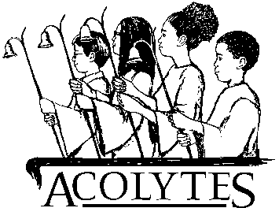

2020 ACOLYTE RECOGNITIONS
Years of Service
Name  Jordan Kowalya  Jordana Nakajubi  Adam Weller-Fahy  Cameron Wigmore  Maya Barry  Addie Collins  Mia McCusker  Charlotte Blount  Melanie Charbonnier  Rachel Moore  Alyson Moore  William Meinhardt  Justin Charbonnier  Elizabeth Meinhardt | Service Years  1st  1st  1st  1st  2nd  2nd  2nd  3rd  4th  4th  5th  5th  8th  10th | Recognition/Notes  Wooden Cross  Wooden Cross  Wooden Cross  Wooden Cross  Silver Cross

Join us for online coffee hour at 11am on Sunday! The Zoom link is found in an email invitation sent on Sunday mornings along with the links to other ways to join us during the week.

