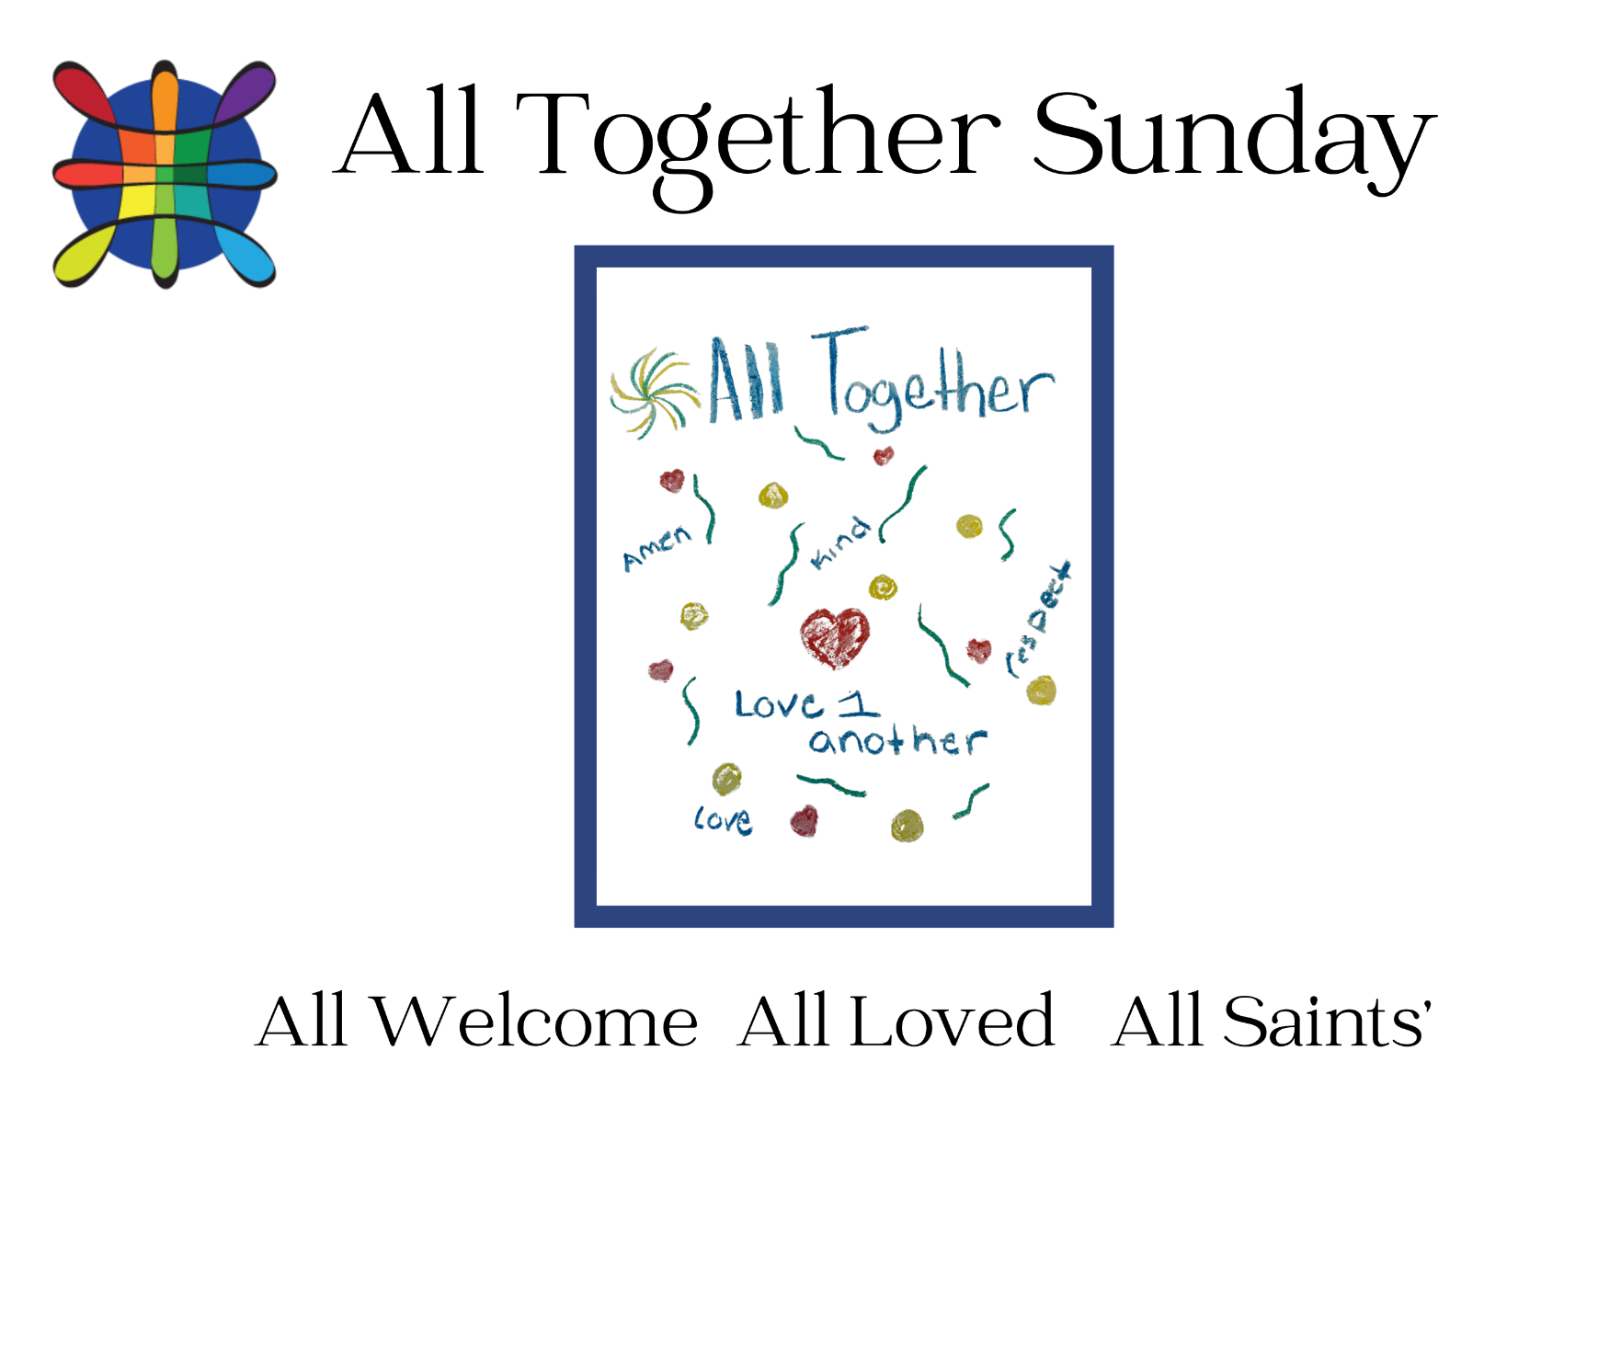

Art from “Pew Art” basket

The Eighteenth Sunday After Pentecost
10:00 AM + October 1, 2023

Welcome! You are invited to participate fully in our worship. Whoever you are, wherever you are on your journey of faith, welcome! Please contact the church office (aschurch@allsaintschelmsford.org) if you would like to receive our weekly e-bulletin..

Crayons have been provided in the pews to facilitate drawing while listening to the service. If you would like to share your pew art, please leave it in the basket in the Narthex labeled: "Pew Art". Thank you!
The Holy Eucharist: Rite Two
The Word of God

Prelude: Bell Choir
Holy God, We Praise Your Name arr by Ron Mallory
Hymn: Come, thou fount of every blessing Black/red hymnal 111
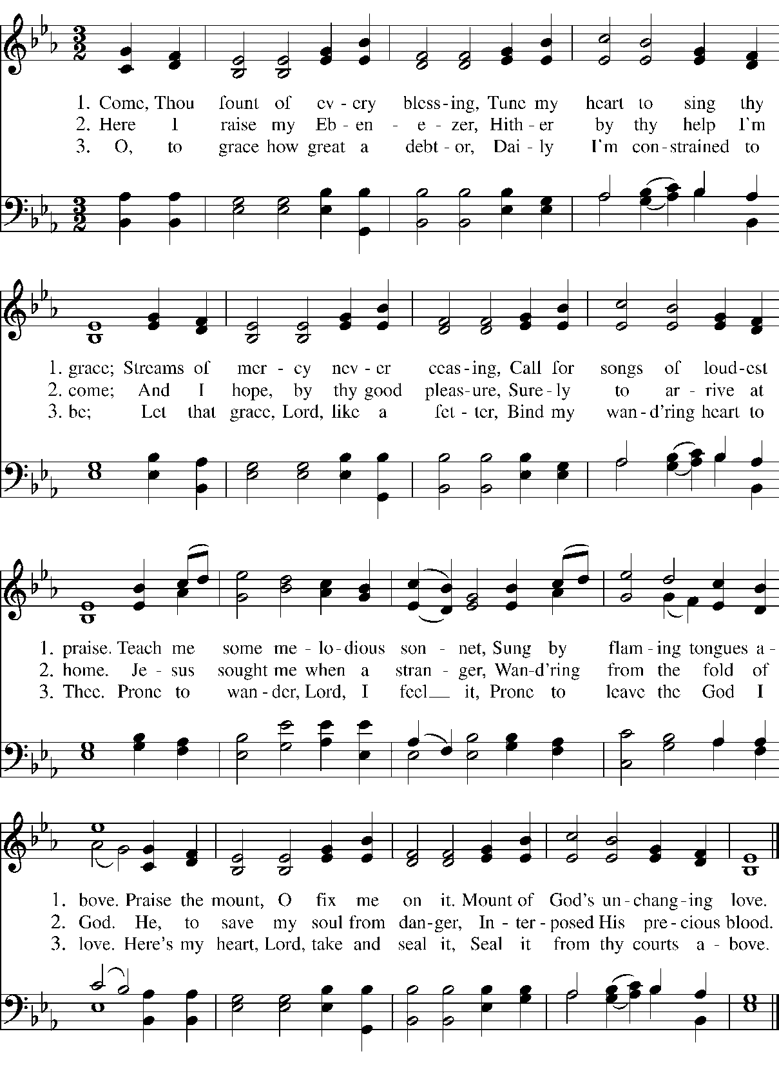

Celebrant: Blessed be God: Father, Son, and Holy Spirit.
People: And blessed be God’s kingdom, now and forever. Amen.

Celebrant: Collect for Purity

Canticle: Glory to God Black/red hymnal 243

Glory, Glory, hallelujah,
Lord we praise your Holy name,
Glory, Glory hallelujah,
Lord we praise your Holy name.
Glory to God in the highest,
and peace to His people on earth.
Lord God, heavenly King,
almighty God and Father,
we worship you, we give you thanks,
we praise you for your glory.
Lord Jesus Christ, only son of the Father,
Lord God, Lamb of God,
You take away the sin of the world:
have mercy on us;
You are seated at the right hand of the Father:
receive our prayer.
For you alone are the Holy One, you alone are the Lord,
You alone are the Most High, Jesus Christ with the Holy Spirit,
in the glory of God the Father. Amen.

Celebrant: The Lord be with you.
People: And also with you.
Celebrant: Together let us pray.

Collect Said in unison
O God, you declare your almighty power chiefly in showing mercy and pity: Grant us the fullness of your grace, that we, running to obtain your promises, may become partakers of your heavenly treasure; through Jesus Christ our Lord, who lives and reigns with you and the Holy Spirit, one God, for ever and ever. Amen.

A Reading from the Book of Exodus 17:1-7
From the wilderness of Sin the whole congregation of the Israelites journeyed by stages, as the Lord commanded. They camped at Rephidim, but there was no water for the people to drink. The people quarreled with Moses, and said, “Give us water to drink.” Moses said to them, “Why do you quarrel with me? Why do you test the Lord?” But the people thirsted there for water; and the people complained against Moses and said, “Why did you bring us out of Egypt, to kill us and our children and livestock with thirst?” So Moses cried out to the Lord, “What shall I do with this people? They are almost ready to stone me.” The Lord said to Moses, “Go on ahead of the people, and take some of the elders of Israel with you; take in your hand the staff with which you struck the Nile, and go. I will be standing there in front of you on the rock at Horeb. Strike the rock, and water will come out of it, so that the people may drink.” Moses did so, in the sight of the elders of Israel. He called the place Massah and Meribah, because the Israelites quarreled and tested the Lord, saying, “Is the Lord among us or not?”In the evening quails came up and covered the camp; and in the morning there was a layer of dew around the camp. When the layer of dew lifted, there on the surface of the wilderness was a fine flaky substance, as fine as frost on the ground. When the Israelites saw it, they said to one another, “What is it?” For they did not know what it was. Moses said to them, “It is the bread that the Lord has given you to eat.”
People’s response after the reading Thanks be to God.

Psalm 78:1-4, 12-16

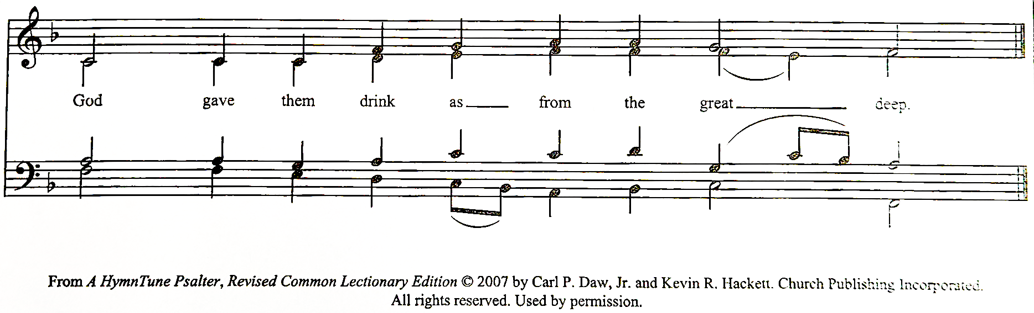

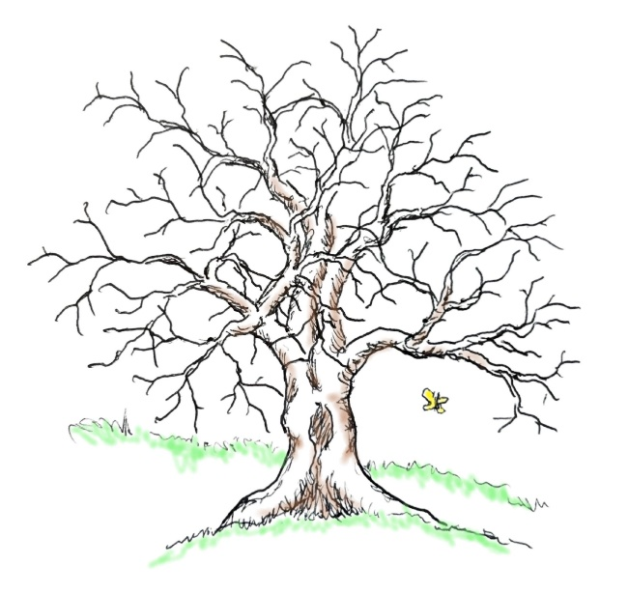
The congregation is asked to sing the antiphon with the choir.
1 Hear my teaching, O my people; *
incline your ears to the words of my mouth.

2 I will open my mouth in a parable; *
I will declare the mysteries of ancient times.

3 That which we have heard and known,
and what our forefathers have told us, *
we will not hide from their children.

4 We will recount to generations to come
the praiseworthy deeds and the power of the LORD, *
and the wonderful works he has done.

12 He worked marvels in the sight of their forefathers, *
in the land of Egypt, in the field of Zoan.

13 He split open the sea and let them pass through; *
he made the waters stand up like walls.

14 He led them with a cloud by day, *
and all the night through with a glow of fire.

15 He split the hard rocks in the wilderness *
and gave them drink as from the great deep.

16 He brought streams out of the cliff, *
and the waters gushed out like rivers.

A Reading from the Letter to the Philippians 2:1-13
If then there is any encouragement in Christ, any consolation from love, any sharing in the Spirit, any compassion and sympathy, make my joy complete: be of the same mind, having the same love, being in full accord and of one mind. Do nothing from selfish ambition or conceit, but in humility regard others as better than yourselves. Let each of you look not to your own interests, but to the interests of others. Let the same mind be in you that was in Christ Jesus,
who, though he was in the form of God,
did not regard equality with God
as something to be exploited,
but emptied himself,
taking the form of a slave,
being born in human likeness.
And being found in human form,
he humbled himself
and became obedient to the point of death--
even death on a cross.
Therefore God also highly exalted him
and gave him the name
that is above every name,
so that at the name of Jesus
every knee should bend,
in heaven and on earth and under the earth,
and every tongue should confess
that Jesus Christ is Lord,
to the glory of God the Father.

Therefore, my beloved, just as you have always obeyed me, not only in my presence, but much more now in my absence, work out your own salvation with fear and trembling; for it is God who is at work in you, enabling you both to will and to work for his good pleasure.
People’s response after the reading Thanks be to God.
Hymn: What does the Lord require of you?
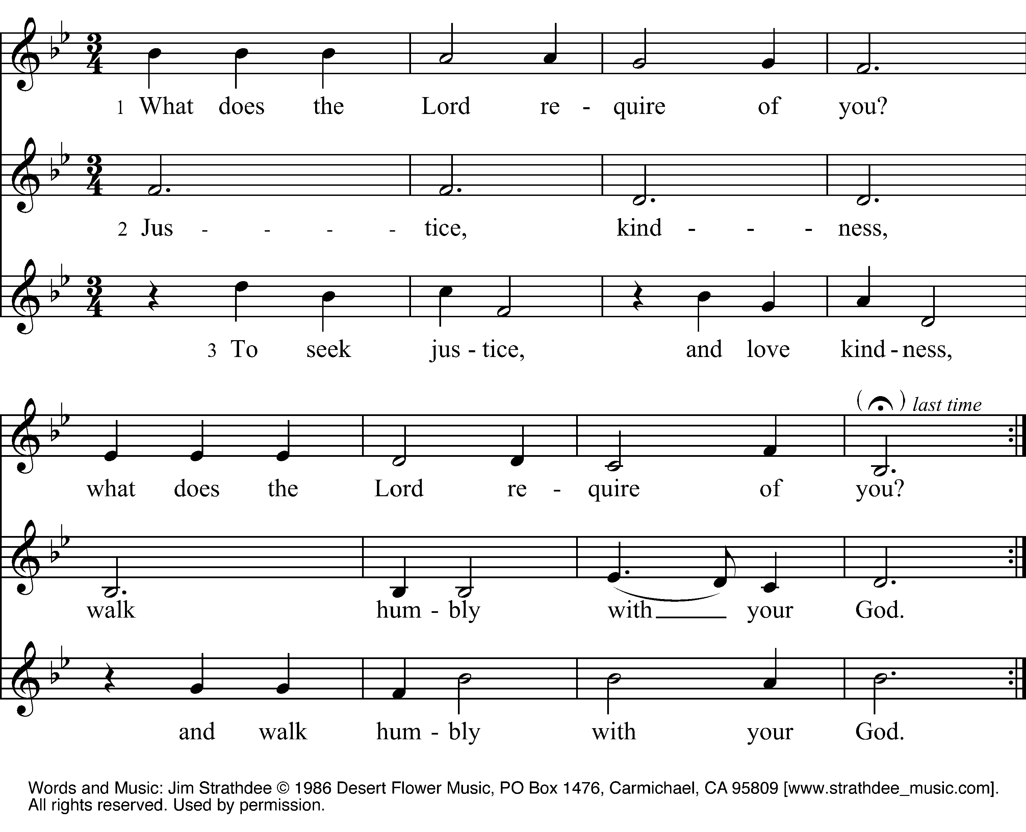
The Holy Gospel according to Matthew 21:23-32
People Said before the reading Glory to you, Lord Christ.
When Jesus entered the temple, the chief priests and the elders of the people came to him as he was teaching, and said, “By what authority are you doing these things, and who gave you this authority?” Jesus said to them, “I will also ask you one question; if you tell me the answer, then I will also tell you by what authority I do these things. Did the baptism of John come from heaven, or was it of human origin?” And they argued with one another, “If we say, ‘From heaven,’ he will say to us, ‘Why then did you not believe him?’ But if we say, ‘Of human origin,’ we are afraid of the crowd; for all regard John as a prophet.” So they answered Jesus, “We do not know.” And he said to them, “Neither will I tell you by what authority I am doing these things.
“What do you think? A man had two sons; he went to the first and said, ‘Son, go and work in the vineyard today.’ He answered, ‘I will not’; but later he changed his mind and went. The father went to the second and said the same; and he answered, ‘I go, sir’; but he did not go. Which of the two did the will of his father?” They said, “The first.” Jesus said to them, “Truly I tell you, the tax collectors and the prostitutes are going into the kingdom of God ahead of you. For John came to you in the way of righteousness and you did not believe him, but the tax collectors and the prostitutes believed him; and even after you saw it, you did not change your minds and believe him.
Said after the reading Praise to you, Lord Christ.

Sermon The Reverend Sean Maloney

The Nicene Creed Spoken by all, standing.
We believe in one God, the Father, the Almighty, maker of heaven and earth, of all that is, seen and unseen.
We believe in one Lord, Jesus Christ, the only Son of God, eternally begotten of the Father, God from God, Light from Light, true God from true God, begotten, not made, of one Being with the Father.
Through him all things were made. For us and for our salvation he came down from heaven: by the power of the Holy Spirit he became incarnate from the Virgin Mary, and was made man. For our sake he was crucified under Pontius Pilate; he suffered death and was buried.
On the third day he rose again in accordance with the Scriptures; he ascended into heaven and is seated at the right hand of the Father.
He will come again in glory to judge the living and the dead, and his kingdom will have no end.
We believe in the Holy Spirit, the Lord, the giver of life, who proceeds from the Father and the Son. With the Father and the Son, he is worshiped and glorified. He has spoken through the Prophets.
We believe in one holy catholic and apostolic Church. We acknowledge one baptism for the forgiveness of sins. We look for the resurrection of the dead, and the life of the world to come. Amen.

Prayers of the People - Form III
Deacon or other leader

Father, we pray for your holy Catholic Church;
That we all may be one.

Grant that every member of the Church may truly and humbly serve you;
That your Name may be glorified by all people.

We pray for all bishops, priests, and deacons;
That they may be faithful ministers of your Word and Sacraments.

We pray for all who govern and hold authority in the nations of the world;
That there may be justice and peace on the earth.

Give us grace to do your will in all that we undertake;
That our works may find favor in your sight.

Have compassion on those who suffer from any grief or trouble;
That they may be delivered from their distress.

Give to the departed eternal rest.
Let light perpetual shine upon them.

We praise you for your saints who have entered into joy;
May we also come to share in your heavenly kingdom.

Let us pray for our own needs and those of others.

Silence
The People may add their own petitions.

The Celebrant adds a concluding Collect.
Silence may be kept.
The Peace
All stand
The peace of the Lord be always with you.
And also with you.
Announcements:
Birthdays and Anniversaries

The Holy Communion

Offertory Anthem: Jesus! Name of Wondrous Love Robert Powell (1932-)

The Great Thanksgiving - Eucharistic Prayer A
Celebrant: The Lord be with you.
People: And also with you.
Celebrant: Lift up your hearts.
People: We lift them to the Lord.
Celebrant: Let us give thanks to the Lord our God.
People: It is right to give God thanks and praise.
Celebrant: It is right, and a good and joyful thing, always and every-
where to give thanks to you, Father Almighty, Creator of heaven and earth.
Therefore we praise you, joining our voices with Angels and Archangels and with all the company of heaven, who forever sing this hymn to proclaim the glory of your Name:
Sanctus: Holy, holy, holy Black/red hymnal 255
Holy, holy, holy, holy, holy Lord God of hosts.
Heaven and earth are filled with your glory.
Hosanna in the highest.
Blessed is He who comes in the name of the Lord, of the Lord.
Hosanna in the highest, hosanna in the highest.

The Celebrant continues
Holy and gracious Father: In your infinite love you made us for yourself, and, when we had fallen into sin and become subject to evil and death, you, in your mercy, sent Jesus Christ, your only and eternal Son, to share our human nature, to live and die as one of us, to reconcile us to you, the
God and Father of all.
He stretched out his arms upon the cross, and offered himself, in obedience to your will, a perfect sacrifice for the whole world.
On the night he was handed over to suffering and death, our Lord Jesus Christ took bread; and when he had given thanks to you, he broke it, and gave it to his disciples, and said, "Take, eat: This is my Body, which is given for you. Do this for the remembrance of me."
After supper he took the cup of wine; and when he had given thanks, he gave it to them, and said, "Drink this, all of you: This is my Blood of the new Covenant, which is shed for you and for many for the forgiveness of sins. Whenever you drink it, do this for the remembrance of me."
Therefore we proclaim the mystery of faith:
Celebrant and People
Christ has died.
Christ is risen.
Christ will come again.
We celebrate the memorial of our redemption, O Father, in this sacrifice of praise and thanksgiving. Recalling his death, resurrection, and ascension, we offer you these gifts. Sanctify them by your Holy Spirit to be for your people the Body and Blood of your Son, the holy food and drink of new and unending life in him. Sanctify us also that we may faithfully receive this holy Sacrament, and serve you in unity, constancy, and peace; and at the last day bring us with all your saints into the joy of your eternal kingdom.
All this we ask through your Son Jesus Christ: By him, and with him, and in him, in the unity of the Holy Spirit all honor and glory is yours, Almighty Father, now and forever. AMEN.
The Lord’s Prayer BCP p. 364
As our Savior Christ has taught us, we are bold to say,
People and Celebrant
Our Father, who art in heaven, hallowed be thy Name,
thy kingdom come, thy will be done, on earth as it is in heaven.
Give us this day our daily bread. And forgive us our trespasses,
as we forgive those who trespass against us. And lead us not into
temptation, but deliver us from evil. For thine is the kingdom,
and the power, and the glory, for ever and ever. Amen.
The Breaking of the Bread
Fraction Anthem: Christ our Passover Black/red hymnal 268

Alleluia, Alleluia, Alleluia
Christ our Passover is sacrificed for us;
Therefore let us keep the feast.
Christ our Passover is sacrificed for us;
Therefore let us keep the feast.
Christ our Passover is sacrificed for us;
Therefore let us keep the feast.
Alleluia, Alleluia, Alleluia

The Gifts You are invited as you feel moved to join us for Communion today. Simply move into the aisle as the Ushers assist you. If you would like to receive communion place your hands out and the priest will give you a piece of bread (or gluten free if needed). You may then receive wine from either the chalice or the individual cup. At this time intinction (dipping) is not permitted. Communion in one kind for any reasons is fully acceptable and has wide use in the tradition. If you don’t want to share in communion but want to share in this holy moment come forward with your hands across your heart to receive a blessing.

Communion Music:
Anthem: Morning glory, starlit sky Dorothy Howell Sheets (1915-2011)

Celebrant Let us pray.
Almighty and everliving God, we thank you for feeding us with the spiritual food of the most precious Body and Blood of your Son our Savior Jesus Christ; and for assuring us in these holy mysteries that we are living members of the Body of your Son, and heirs of your eternal kingdom.
And now, Father, send us out to do the work you have given us to do, to love and serve you as faithful witnesses of Christ our Lord. To him, to you, and to the Holy Spirit, be honor and glory, now and for ever. Amen.
Blessing
Hymn: Lord, dismiss us with thy blessing Blue hymnal 344

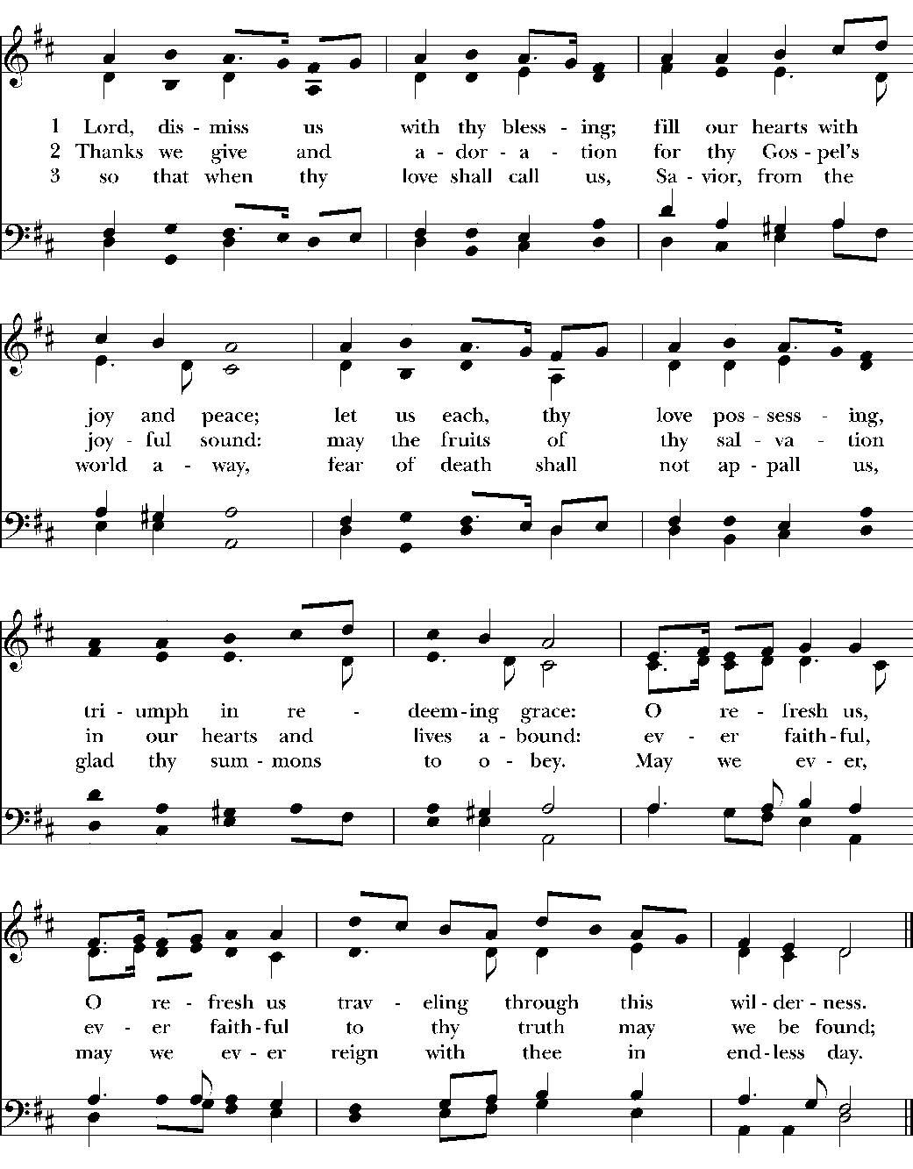
The Dismissal
Postlude: Minuet G.F. Handel (1685-1759)

