### Second Sunday of Advent

### 10:00 AM + December 8th, 2024

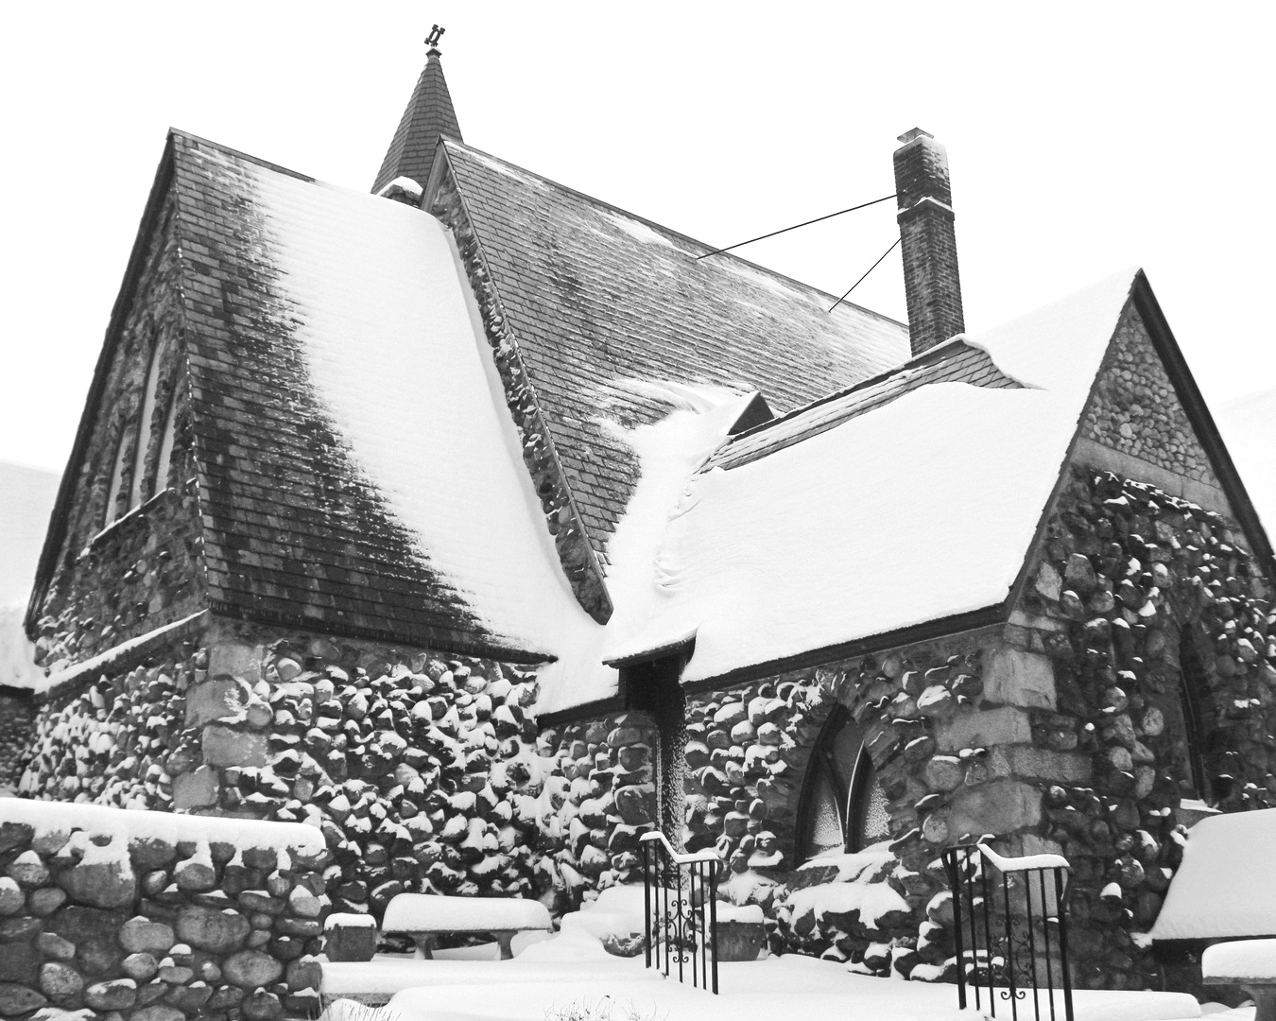

Welcome!  
You are invited to participate fully in our worship. Whoever you are, wherever you are on your journey of faith, welcome!

## The Holy Eucharist: Rite Two

## The Word of God

**Prelude:** Variations on *BESANÇON:* Var. 1-3 Benjamin Cornelius-Bates

***The Lighting of the Advent Wreath***  *to the tune of Away in a Manger*

A candle is burning, a candle of PEACE.

A candle to signal that conflict must cease.

For Jesus is coming to show us the way,

A message of peace humbly laid in the hay.

**Opening Hymn:** “On Jordan’s bank the Baptist’s cry” Blue Hymnal 76

*Celebrant: Blessed are you, holy and living One.*

*People:* ***You come to your people and set them free****.*

*Celebrant:* Almighty God, to you all hearts are open, all desires known, and from you no secrets are hid: Cleanse the thoughts of our hearts by the inspiration of your Holy Spirit, that we may perfectly love you, and worthily magnify your holy Name; through Christ our Lord. Amen.

**Kyrie:** Lord, have mercy upon us Blue Hymnal S91

*Celebrant:* The Lord be with you.

*People:* **And also with you.**

*Celebrant:* Let us pray.

The Collect *Said in unison*

Merciful God, who sent your messengers the prophets to preach repentance and prepare the way for our salvation: Give us grace to heed their warnings and forsake our sins, that we may greet with joy the coming of Jesus Christ our Redeemer; who lives and reigns with you and the Holy Spirit, one God, now and for ever.**Amen.**

**A Reading from the Book of** **Malachi 3:1-4**

See, I am sending my messenger to prepare the way before me, and the Lord whom you seek will suddenly come to his temple. The messenger of the covenant in whom you delight-- indeed, he is coming, says the Lord of hosts. But who can endure the day of his coming, and who can stand when he appears?

For he is like a refiner's fire and like fullers' soap; he will sit as a refiner and purifier of silver, and he will purify the descendants of Levi and refine them like gold and silver, until they present offerings to the Lord in righteousness. Then the offering of Judah and Jerusalem will be pleasing to the Lord as in the days of old and as in former years.

*People’s response after the reading* **Thanks be to God.**

**Psalm**  **Canticle 16 Page 92, BCP**

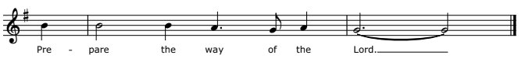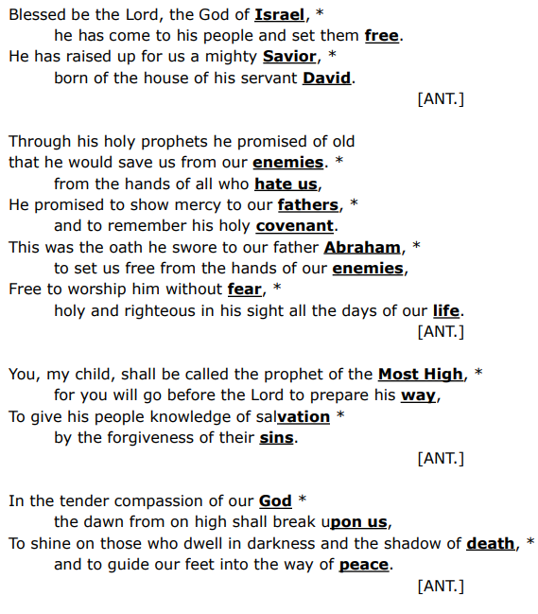

**A Reading from the Book of Philippians 1:3-11**

I thank my God every time I remember you, constantly praying with joy in every one of my prayers for all of you, because of your sharing in the gospel from the first day until now. I am confident of this, that the one who began a good work among you will bring it to completion by the day of Jesus Christ. It is right for me to think this way about all of you, because you hold me in your heart, for all of you share in God's grace with me, both in my imprisonment and in the defense and confirmation of the gospel. For God is my witness, how I long for all of you with the compassion of Christ Jesus. And this is my prayer, that your love may overflow more and more with knowledge and full insight to help you to determine what is best, so that in the day of Christ you may be pure and blameless, having produced the harvest of righteousness that comes through Jesus Christ for the glory and praise of God.

People’s *response after the reading* **Thanks be to God.**

**Hymn:** “Prepare the way, O Zion” Blue Hymnal 65

(vv 1 & 2 before Gospel; v. 3 after Gospel)

**The Holy Gospel according to Luke 3:1-6**

*People’s response before the Gospel* **Glory to you, Lord Christ.**

In the fifteenth year of the reign of Emperor Tiberius, when Pontius Pilate was governor of Judea, and Herod was ruler of Galilee, and his brother Philip ruler of the region of Ituraea and Trachonitis, and Lysanias ruler of Abilene, during the high priesthood of Annas and Caiaphas, the word of God came to John son of Zechariah in the wilderness. He went into all the region around the Jordan, proclaiming a baptism of repentance for the forgiveness of sins, as it is written in the book of the words of the prophet Isaiah,

"The voice of one crying out in the wilderness:

'Prepare the way of the Lord,  
make his paths straight.

Every valley shall be filled,  
and every mountain and hill shall be made low,

and the crooked shall be made straight,  
and the rough ways made smooth;

and all flesh shall see the salvation of God.'"

*People’s response after the Gospel* **Praise to you, Lord Christ.**

The Sermon Amy Hunter

The Nicene Creed *Spoken by all, standing.*

**We believe in one God, the Father, the Almighty, maker of heaven and earth, of all that is, seen and unseen.**

**We believe in one Lord, Jesus Christ, the only Son of God, eternally begotten of the Father, God from God, Light from Light, true God from true God, begotten, not made, of one Being with the Father. Through him all things were made. For us and for our salvation he came down from heaven: by the power of the Holy Spirit he became incarnate from the Virgin Mary, and was made man. For our sake he was crucified under Pontius Pilate; he suffered death and was buried. On the third day he rose again in accordance with the Scriptures; he ascended into heaven and is seated at the right hand of the Father. He will come again in glory to judge the living and the dead, and his kingdom will have no end.**

**We believe in the Holy Spirit, the Lord, the giver of life, who proceeds from the Father and the Son. With the Father and the Son, he is worshiped and glorified. He has spoken through the Prophets.**

**We believe in one holy catholic and apostolic Church. We acknowledge one baptism for the forgiveness of sins. We look for the resurrection of the dead, and the life of the world to come. Amen.**

Prayers of the People - from Hear Our Prayer: Prayers of the People for the Revised Common Lectionary

*The Leader and People pray responsively*

Holy God, wherever we are, you are there. Stir our hearts wherever we may go that we may see you and offer thanksgiving for the life you have given us. Hear these prayers we offer as we say, Lord in your mercy, hear our prayer.

For the church in every place: May we be ever mindful of the richness of the family of the God’s people, those next to us here, those in neighborhood churches, and those worshipping today across the globe. Help us to grow into a unity of mission and ministry in our common devotion to Christ that we might be faithful witnesses of your love. Lord in your mercy, **hear our prayer.**

For those in civil authority: That they be guided by hope and not fear. Lord in your mercy, **hear our prayer.**

For this faith community; amid joys and sorrow: Let us remember those who have gone before us; those who have sacrificed for us. Let us give thanks for this gathering of God’s people and for the renewal of life we are given. Lord in your mercy, **hear our prayer.**

For the gifts of creation, for the sun that lights our day and the moon and stars that shelter the night: May our eyes be open to the beauty around us. Help us to protect and nurture the creation and ever proclaim its wonders. Lord in your mercy, **hear our prayer.**

For those at greatest risk among us: Let us pray for those who are lonely or neglected, and for those facing illness and disability. [Especially we pray for…*prayer list*] Lord in your mercy, **hear our prayer.**

For those who have died, for those who are dying, and for those who grieve, that they might find hope your promise of lasting life. Lord in your mercy, **hear our prayer.**

Lord, gather up our prayers with those of all your people in every place and time, and guide us to Christ, preparing the way for us by making every valley filled and every mountain low. **Amen.**

## Confession of Sin

*Celebrant:* Let us confess our sins to God. (Silence may be kept.)

**God of all mercy, we confess that we have sinned against you, opposing your will in our lives. We have denied your goodness in each other, in ourselves, and in the world you have created. We repent of the evil that enslaves us, the evil we have done, and the evil done on our behalf.**

**Forgive, restore, and strengthen us through our Savior Jesus Christ, that we may abide in your love and serve only your will. Amen.**

**Absolution**

Almighty God have mercy on you, forgive you all your sins through the grace of Jesus Christ, strengthen you in all goodness, and by the power of the Holy Spirit keep you in eternal life. Amen.

The Peace *All stand*

*Celebrant:* The peace of the Lord be always with you.

*People:* **And also with you**.

## Announcements:

**The Holy Communion**

## Offertory Anthem: Comfort, Comfort Ye, My People

Words: J. G. Olearius (tr. Catherine Winkworth)

Music: Genevan Psalter Melody

## The Great Thanksgiving – *Eucharistic Prayer 2*

## *Celebrant:* The Lord be with you.

## *People:* And also with you.

## *Celebrant:* Lift up your hearts.

## *People:* We lift them to the Lord.

## *Celebrant*: Let us give thanks to the Lord our God.

## *People:* It is right to give our thanks and praise.

## *Celebrant:* We praise you and we bless you, holy and gracious God, source of life abundant. From before time you made ready the creation. Your Spirit moved over the deep and brought all things into being: sun, moon, and stars; earth, winds, and waters; and every living thing. You made us in your image, and taught us to walk in your ways. But we rebelled against you, and wandered far away; and yet, as a mother cares for her children, you would not forget us. Time and again you called us to live in the fullness of your love. And so this day we join with Saints and Angels in the chorus of praise that rings through eternity, lifting our voices to magnify you as we sing (say):

**Sanctus:** Holy, Holy, Holy Blue Hymnal S 114

**Holy, Holy, Holy Lord, God of power and might,**

**heaven and earth are full of your glory.**

**Hosanna in the highest.**

**Blessed is he who comes in the name of the Lord.**

**Hosanna in the highest.**

**The people stand or kneel.**

Glory and honor and praise to you, holy and living God. To deliver us from the power of sin and death and to reveal the riches of your grace, you looked with favor upon Mary, your willing servant, that she might conceive and bear a son, Jesus the holy child of God. Living among us, Jesus loved us. He broke bread with outcasts and sinners, healed the sick, and proclaimed good news to the poor. He yearned to draw all the world to himself yet we were heedless of his call to walk in love. Then, the time came for him to complete upon the cross the sacrifice of his life, and to be glorified by you.

On the night before he died for us, Jesus was at table with his friends. He took bread, gave thanks to you, broke it, and gave it to them, and said: “Take, eat: This is my Body, which is given for you. Do this for the remembrance of me.”

As supper was ending, Jesus took the cup of wine. Again, he gave thanks to you, gave it to them, and said: “Drink this, all of you: This is my Blood of the new Covenant, which is poured out for you and for all for the forgiveness of sins. Whenever you drink it, do this for the remembrance of me.”

Now gathered at your table, O God of all creation, and remembering Christ, crucified and risen, who was and is and is to come, we offer to you our gifts of bread and wine, and ourselves, a living sacrifice.

Pour out your Spirit upon these gifts that they may be the Body and Blood of Christ. Breathe your Spirit over the whole earth and make us your new creation, the Body of Christ given for the world you have made.

In the fullness of time bring us, with [___________ and] all your saints, from every tribe and language and people and nation, to feast at the banquet prepared from the foundation of the world.

Through Christ and with Christ and in Christ, in the unity of the Holy Spirit, to you be honor, glory, and praise, for ever and ever. AMEN.

Therefore we proclaim the mystery of the faith:

*Celebrant and People*

**Christ has died.**

**Christ is risen.**

**Christ will come again.**

*The Celebrant continues*

We celebrate the memorial of our redemption, O Father, in this sacrifice of praise and thanksgiving. Recalling his death, resurrection, and ascension, we offer you these gifts.

Sanctify them by your Holy Spirit to be for your people the Body and Blood of your Son, the holy food and drink of new and unending life in him. Sanctify us also that we may faithfully receive this holy Sacrament, and serve you in unity, constancy, and peace; and at the last day bring us with all your saints into the joy of your eternal kingdom.

All this we ask through your Son Jesus Christ: By him, and with him, and in him, in the unity of the Holy Spirit all honor and glory is yours, Almighty Father, now and for ever. **AMEN.**

And now, as our Savior Christ has taught us, we are bold to say,

**Our Father, who art in heaven, hallowed be thy Name, thy kingdom come, thy will be done, on earth as it is in heaven.**

**Give us this day our daily bread.**

**And forgive us our trespasses,   
as we forgive those who trespass against us.**

**And lead us not into temptation, but deliver us from evil.**

**For thine is the kingdom, and the power, and the glory,   
for ever and ever. Amen.**

## The Breaking of the Bread

Alleluia, Christ our Passover is sacrificed for us;

**Therefore let us keep the feast. Alleluia,**

**Fraction Anthem:** O Lamb of God Blue Hymnal S 158

**Communion Music:** People, Look East

Words: Eleanor Farjeon

Music: *BESANÇON CAROL*, harm. John L. Hooker

**The Post Communion Prayer**

*Celebrant and People*

**Eternal God, heavenly Father, you have graciously accepted us as living members of your Son our Savior Jesus Christ, and you have fed us with spiritual food in the Sacrament of his Body and Blood. Send us now into the world in peace, and grant us strength and courage to love and serve you with gladness and singleness of heart; through Christ our Lord. Amen.**

**Hymn:** “Lord divine, all loves excelling” Blue Hymnal 657

## The Dismissal

*Celebrant:* Let us go forth in the name of Christ.

*People:* **Thanks be to God. Alleluia, Alleluia, Alleluia.**

**Postlude:** Variations on *BESANÇON:* Var. 4 Benjamin Cornelius-Bates



## Thank you for joining us today!

if you would like to receive our weekly e-bulletin, please contact the church office (aschurch@allsaintschelmsford.org) To learn more about us, visit https://www.allsaintschelmsford.org or call us at 978