### First Sunday after the Epiphany

### 10:00 AM + January 12th, 2025

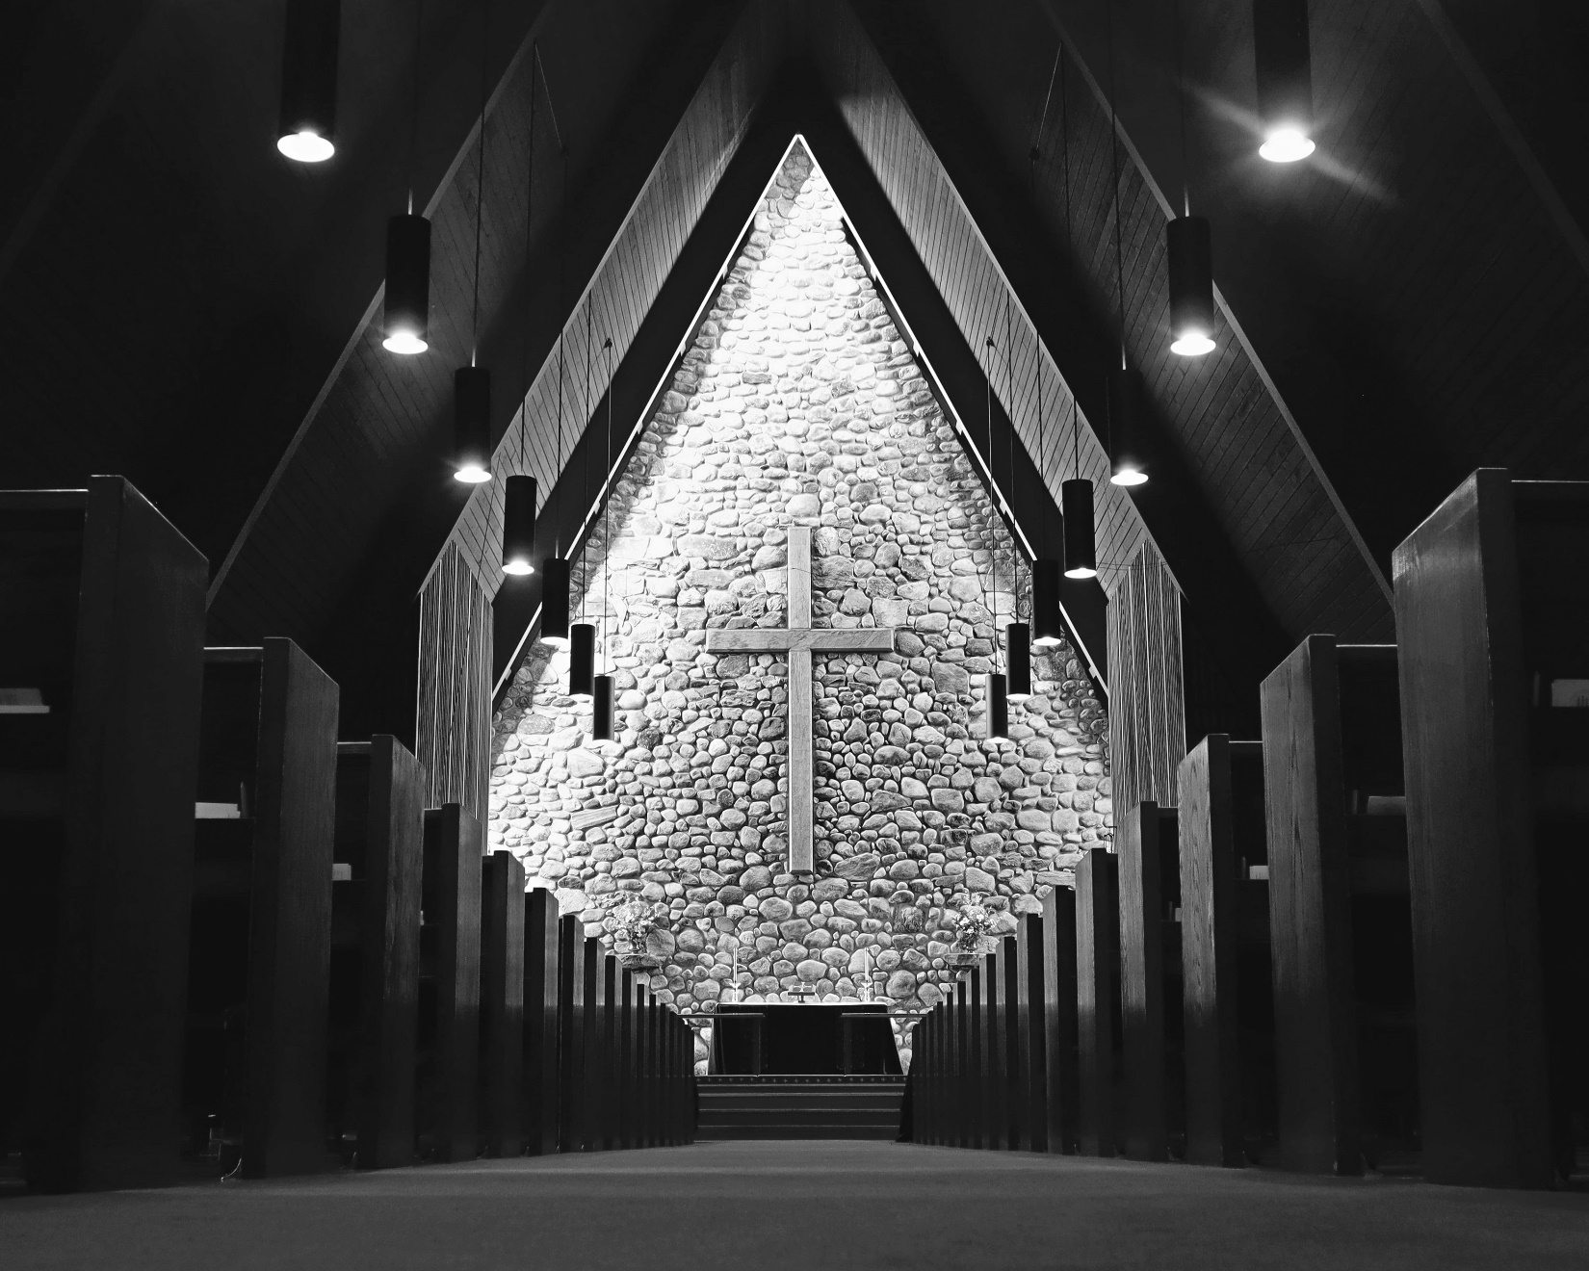

Welcome!  
You are invited to participate fully in our worship. Whoever you are, wherever you are on your journey of faith, welcome!

## The Holy Eucharist: Rite Two

## The Word of God

**Prelude: Prelude** Stanley Winn

**Opening Hymn:** “O love, how deep, how broad, how high” Blue Hymnal 448 (omit * verse)

*Celebrant:* Blessed be God: Father, Son, and Holy Spirit.

*People:* **And blessed be God’s kingdom, now and for ever. Amen.**

*Celebrant:* Almighty God, to you all hearts are open, all desires known, and from you no secrets are hid: Cleanse the thoughts of our hearts by the inspiration of your Holy Spirit, that we may perfectly love you, and worthily magnify your holy Name; through Christ our Lord. Amen.

Gloria: Glory to God *Blue Hymnal S 280*

**Glory to God in the highest,**

**and peace to his people on earth.**

**Lord God, heavenly King, almighty God and Father,**

**we worship you, we give you thanks,**

**we praise you for your glory.**

**Lord Jesus Christ, only Son of the Father,**

**Lord God, Lamb of God, you take away the sin of the world:**

**have mercy on us;**

**you are seated at the right hand of the Father:**

**receive our prayer.**

**For you alone are the Holy One,**

**you alone are the Lord, you alone are the Most High,**

**Jesus Christ, with the Holy Spirit,**

**in the glory of God the Father. Amen.**

*Celebrant:* The Lord be with you.

*People:* **And also with you.**

*Celebrant:* Let us pray.

The Collect *Said in unison*

Father in heaven, who at the baptism of Jesus in the River Jordan proclaimed him your beloved Son and anointed him with the Holy Spirit: Grant that all who are baptized into his Name may keep the covenant they have made, and boldly confess him as Lord and Savior; who with you and the Holy Spirit lives and reigns, one God, in glory everlasting. ***Amen*.**

**A Reading from the Prophet Isaiah 43:1-7**

Thus says the Lord,  
he who created you, O Jacob,

he who formed you, O Israel:

Do not fear, for I have redeemed you;  
I have called you by name, you are mine.

When you pass through the waters, I will be with you;  
and through the rivers, they shall not overwhelm you;

when you walk through fire you shall not be burned,  
and the flame shall not consume you.

For I am the Lord your God,  
the Holy One of Israel, your Savior.

I give Egypt as your ransom,  
Ethiopia and Seba in exchange for you.

Because you are precious in my sight,  
and honored, and I love you,

I give people in return for you,  
nations in exchange for your life.

Do not fear, for I am with you;  
I will bring your offspring from the east,  
and from the west I will gather you;

I will say to the north, "Give them up,"  
and to the south, "Do not withhold;

bring my sons from far away  
and my daughters from the end of the earth--

everyone who is called by my name,  
whom I created for my glory,  
whom I formed and made."

*Celebrant:* The Word of the Lord

*People:* **Thanks be to God**

**Psalm** **29**

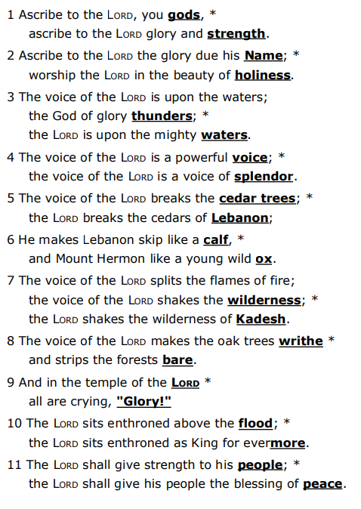

**A Reading from Acts 8:14-17**

When the apostles at Jerusalem heard that Samaria had accepted the word of God, they sent Peter and John to them. The two went down and prayed for them that they might receive the Holy Spirit (for as yet the Spirit had not come upon any of them; they had only been baptized in the name of the Lord Jesus). Then Peter and John laid their hands on them, and they received the Holy Spirit.

*People:* **Thanks be to God**

**Sequence Hymn:** “How firm a foundation” Blue Hymnal 636 (vv. 1&2 before Gospel; v. 3 after Gospel)

**The Holy Gospel according to Luke 3:15-17, 21-22**

As the people were filled with expectation, and all were questioning in their hearts concerning John, whether he might be the Messiah, John answered all of them by saying, "I baptize you with water; but one who is more powerful than I is coming; I am not worthy to untie the thong of his sandals. He will baptize you with the Holy Spirit and fire. His winnowing fork is in his hand, to clear his threshing floor and to gather the wheat into his granary; but the chaff he will burn with unquenchable fire."

Now when all the people were baptized, and when Jesus also had been baptized and was praying, the heaven was opened, and the Holy Spirit descended upon him in bodily form like a dove. And a voice came from heaven, "You are my Son, the Beloved; with you I am well pleased."

*People’s response before the Gospel* **Glory to you, Lord Christ.**

The Sermon Rev. Sean Maloney

The Nicene Creed *Spoken by all, standing.*

**We believe in one God, the Father, the Almighty, maker of heaven and earth, of all that is, seen and unseen.**

**We believe in one Lord, Jesus Christ, the only Son of God, eternally begotten of the Father, God from God, Light from Light, true God from true God, begotten, not made, of one Being with the Father. Through him all things were made. For us and for our salvation he came down from heaven: by the power of the Holy Spirit he became incarnate from the Virgin Mary, and was made man. For our sake he was crucified under Pontius Pilate; he suffered death and was buried. On the third day he rose again in accordance with the Scriptures; he ascended into heaven and is seated at the right hand of the Father. He will come again in glory to judge the living and the dead, and his kingdom will have no end.**

**We believe in the Holy Spirit, the Lord, the giver of life, who proceeds from the Father and the Son. With the Father and the Son, he is worshiped and glorified. He has spoken through the Prophets.**

**We believe in one holy catholic and apostolic Church. We acknowledge one baptism for the forgiveness of sins. We look for the resurrection of the dead, and the life of the world to come. Amen.**

Prayers of the People - from Hear Our Prayer: Prayers of the People for the Revised Common Lectionary, *The Leader and People pray responsively*

Glorious and Wondrous God, in thankfulness and condifence we lift our hopes and needs to you in prayer as we say, Lord in your mercy, hear our prayer.

Raise up in your church leaders whose lives are centered in the love of Christ and whose hearts yearn for justice and peace. Lord in your mercy, **hear our prayer.**

Enter into the hearts of those with authority in our nation that they might work for the fellowship of all people and bring about a world where enemies are reconciled and conflict ceases. Lord in your mercy, **hear our prayer.**

Inspire this assembly through the inbreaking of the Spirit in our lives that our faiths may be bolstered and our commitment to the gospel mission renewed. Lord in your mercy, **hear our prayer.**

Instill in us awe and thankfulness for the majesty of your created world that we might be good stewards and develop sustainable practices so that nature’s abundance might be available to all future generations. Lord in your mercy, **hear our prayer.**

Bring healing to the sick and hurting, mend the fractured and broken, grant hope to the fearful and anxious, and grant peace and the knowledge of your love to all people. [Especially we pray for…*prayer list*] Lord in your mercy, **hear our prayer.**

Grant to us the faithful departed peace and rest in your eternal love and, welcome us into the resurrection alongside all your saints. Lord in your mercy, **hear our prayer.**

Hear our prayers and grant our desires as may be best for us and in ways that show forth your grace and mercy. All this we ask through our only advocate and Lord, Jesus, who is Christ and lives with you and the Holy Spirit, one God, forever and ever. **Amen.**

## Confession of Sin

*Celebrant:* Let us confess our sins to God. (Silence may be kept.)

**God of all mercy, we confess that we have sinned against you, opposing your will in our lives. We have denied your goodness in each other, in ourselves, and in the world you have created. We repent of the evil that enslaves us, the evil we have done, and the evil done on our behalf.**

**Forgive, restore, and strengthen us through our Savior Jesus Christ, that we may abide in your love and serve only your will. Amen.**

**Absolution**

Almighty God have mercy on you, forgive you all your sins through the grace of Jesus Christ, strengthen you in all goodness, and by the power of the Holy Spirit keep you in eternal life. Amen.

The Peace *All stand*

*Celebrant:* The peace of the Lord be always with you.

*People:* **And also with you**.

## Announcements:

**The Holy Communion**

## The Great Thanksgiving - *Eucharistic Prayer 1*

**Offertory Hymn:** “Brightest and Best of the Stars” *Morning Star;* James Proctor Harding (arr by Bruce W. Tippette)

*Celebrant* The Lord be with you.

*People* **And also with you.**

*Celebrant*  Lift up your hearts.

*People* **We lift them to the Lord.**

*Celebrant* Let us give thanks to the Lord our God.

*People*  **It is right to give our thanks and praise.**

Celebrant

It is truly right, and good and joyful,

to give you thanks, all-holy God,

source of life and fountain of mercy.

You have filled us and all creation with your blessing

and fed us with your constant love;

you have redeemed us in Jesus Christ

and knit us into one body.

Through your Spirit you replenish us

and call us to fullness of life.

Therefore, joining with Angels and Archangels

and with the faithful of every generation,

we lift our voices with all creation as we sing (say):

Sanctus: Blue Hymnal S 129

*Celebrant and People*

**Holy, holy, holy Lord, God of power and might,**

**heaven and earth are full of your glory.**

**Hosanna in the highest.**

**Blessed is the one who comes in the name of the Lord.**

**Hosanna in the highest.**

Blessed are you, gracious God,

creator of the universe and giver of life.

You formed us in your own image

and called us to dwell in your infinite love.

You gave the world into our care

that we might be your faithful stewards

and show forth your bountiful grace.

But we failed to honor your image

in one another and in ourselves;

we would not see your goodness in the world around us;

and so we violated your creation,

abused one another,

and rejected your love.

Yet you never ceased to care for us,

and prepared the way of salvation for all people.

Through Abraham and Sarah

you called us into covenant with you.

You delivered us from slavery,

sustained us in the wilderness,

and raised up prophets

to renew your promise of salvation.

Then, in the fullness of time,

you sent your eternal Word,

made mortal flesh in Jesus.

Born into the human family,

and dwelling among us,

he revealed your glory.

Giving himself freely to death on the cross,

he triumphed over evil,

opening the way of freedom and life.

On the night before he died for us,

Our Savior Jesus Christ took bread,

and when he had given thanks to you,

he broke it, and gave it to his friends, and said:

“Take, eat:

This is my Body which is given for you.

Do this for the remembrance of me.”

As supper was ending, Jesus took the cup of wine,

and when he had given thanks,

he gave it to them, and said:

“Drink this, all of you:

This is my Blood of the new Covenant,

which is poured out for you and for all

for the forgiveness of sins.

Whenever you drink it,

do this for the remembrance of me.”

Therefore we proclaim the mystery of faith:

Christ has died.

Christ is risen.

Christ will come again.

Remembering his death and resurrection,

we now present to you from your creation

this bread and this wine.

By your Holy Spirit may they be for us

the Body and Blood of our Savior Jesus Christ.

Grant that we who share these gifts

may be filled with the Holy Spirit

and live as Christ’s Body in the world.

Bring us into the everlasting heritage

of your daughters and sons,

that with [ ___________ and] all your saints,

past, present, and yet to come,

we may praise your Name for ever.

Through Christ and with Christ and in Christ,

in the unity of the Holy Spirit,

to you be honor, glory, and praise,

for ever and ever. **AMEN.**

And now, as our Savior Christ has taught us, we are bold to say,

**Our Father, who art in heaven, hallowed be thy Name, thy kingdom come, thy will be done, on earth as it is in heaven.**

**Give us this day our daily bread.**

**And forgive us our trespasses,   
as we forgive those who trespass against us.**

**And lead us not into temptation, but deliver us from evil.**

**For thine is the kingdom, and the power, and the glory,   
for ever and ever. Amen.**

## The Breaking of the Bread

Alleluia, Christ our Passover is sacrificed for us;

**Therefore let us keep the feast. Alleluia.**

**Fraction Anthem:** Christ our Passover Blue Hymnal S 155

**Communion Music:** You Shall Cross the Barren Desert Words and Music: Bob Dufford, SJ

*Celebrant and People*

**Eternal God, heavenly Father, you have graciously accepted us as living members of your Son our Savior Jesus Christ, and you have fed us with spiritual food in the Sacrament of his Body and Blood. Send us now into the world in peace, and grant us strength and courage to love and serve you with gladness and singleness of heart; through Christ our Lord. Amen.**

**Closing Hymn:** ”The sinless one to Jordan Came**”** Blue Hymnal 120

## The Dismissal

*Celebrant:* Let us go forth in the name of Christ.

*People:* **Thanks be to God. Alleluia, Alleluia, Alleluia.**

**Postlude:** Voluntary in G Henry Heron

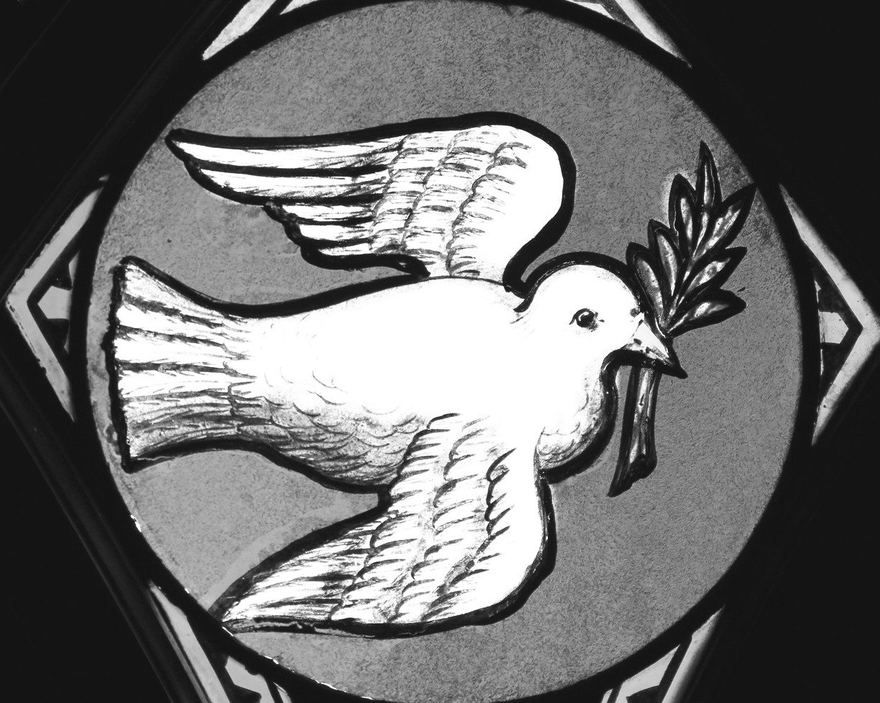

## Thank you for joining us today!

if you would like to receive our weekly e-bulletin, please contact the church office (aschurch@allsaintschelmsford.org) To learn more about us, visit https://www.allsaintschelmsford.org or call us at 978 256 5673.