**The Second Sunday after the Epiphany**

**10:00 AM** + **January 19, 2025**

Welcome! You are invited to participate fully in our worship. Whoever you are, wherever you are on your journey of faith, welcome!

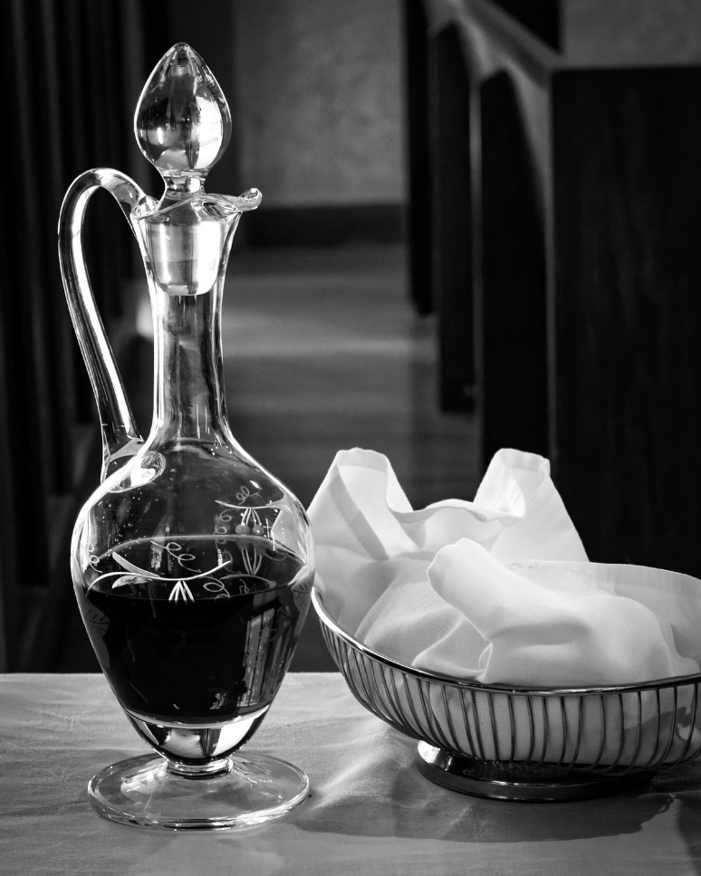

**Morning Prayer: Rite Two**

**Prelude:** Cantabile Alexander Guilmant

**Opening Hymn:** “How bright appears the Morning Star” Blue Hymnal 497

**Opening Sentences**

Officiant Send out your light and your truth, that they may lead me, and bring me to your holy hill and to your dwelling. *Psalm 43:3*

Brothers and sisters in Christ, let us praise and worship God who has called us together. Let us celebrate God’s majesty, and delight in the wonder of God’s love. Together we shall confess our sins and receive assurance that we are forgiven.

As the scriptures are read, we can allow God’s word to speak to us, and ponder its meaning for our lives.

In our prayers, we give thanks for God’s goodness, we pray for others as well as for ourselves, and we offer our lives anew in Christ’s service.

All this we do, because we believe in the presence among us of our Saviour Jesus Christ, and in the mighty power of the Holy Spirit. (from A New Zealand Prayer Book)

**Confession**

Officiant Let us confess our sins to God. *(Silence may be kept.)*

**God of all mercy, we confess that we have sinned against you, opposing your will in our lives. We have denied your goodness in each other, in ourselves, and in the world you have created. We repent of the evil that enslaves us, the evil we have done, and the evil done on our behalf.**

**Forgive, restore, and strengthen us through our Savior Jesus Christ, that we may abide in your love and serve only your will. Amen.**

**Absolution**

Almighty God have mercy on us, forgive us all your sins through the grace of Jesus Christ, strengthen us in all goodness, and by the power of the Holy Spirit keep us in eternal life. Amen.

**The Invitatory and Psalter**

Officiant Lord, open our lips.

**People** **And our mouth shall proclaim your praise.**

Officiant and People: **Glory to the Father, and to the Son, and to the Holy Spirit: as it was in the beginning, is now, and will be for ever. Amen. Alleluia.**

Officiant Worship the Lord in the beauty of holiness:

**People** **Come let us adore him.**

**Jubilate *Psalm Spoken by all***

Be joyful in the Lord, all you lands; *  
    serve the Lord with gladness  
    and come before his presence with a song.

Know this: The Lord himself is God; *  
    he himself has made us, and we are his;  
    we are his people and the sheep of his pasture.

Enter his gates with thanksgiving;  
go into his courts with praise; *  
    give thanks to him and call upon his Name.

For the Lord is good;  
his mercy is everlasting; *  
    and his faithfulness endures from age to age.

Officiant Worship the Lord in the beauty of holiness:

**People** **Come let us adore him.**

**Psalm 36:5-10 *Said responsively***

5 Your love, O Lord, reaches to the heavens, *  
 **and your faithfulness to the clouds.**

6 Your righteousness is like the strong mountains,  
your justice like the great deep; *  
**you save both man and beast, O Lord.**

7 How priceless is your love, O God! *  
**your people take refuge under the shadow of your wings.**

8 They feast upon the abundance of your house; *  
**you give them drink from the river of your delights.**

9 For with you is the well of life, *  
**and in your light we see light.**

10 Continue your loving-kindness to those who know you, *  
**and your favor to those who are true of heart.**

**Glory to the Father, and to the Son, and to the Holy Spirit:\***

**as it was in the beginning, is now, and will be for ever. Amen.**

**The Lessons**

**A Reading from the Prophet Isaiah *Isaiah 62:1-5***

For Zion’s sake I will not keep silent, and for Jerusalem’s sake I will not rest, until her vindication shines out like the dawn, and her salvation like a burning torch. The nations shall see your vindication, and all the kings your glory; and you shall be called by a new name that the mouth of the Lord will give. You shall be a crown of beauty in the hand of the Lord, and a royal diadem in the hand of your God. You shall no more be termed Forsaken, and your land shall no more be termed Desolate; but you shall be called My Delight Is in Her, and your land Married; for the Lord delights in you, and your land shall be married. For as a young man marries a young woman, so shall your builder marry you, and as the bridegroom rejoices over the bride, so shall your God rejoice over you.

*Lector* The Word of the Lord

*People’s response after the reading* **Thanks be to God.**

**A Song of Praise *Song of the Three Young Men, 29-34* (in Unison)**

**Glory to you, Lord God of our fathers; *  
    you are worthy of praise; glory to you.  
Glory to you for the radiance of your holy Name; *  
    we will praise you and highly exalt you for ever.**

**Glory to you in the splendor of your temple; *  
    on the throne of your majesty, glory to you.  
Glory to you, seated between the Cherubim; *  
    we will praise you and highly exalt you for ever.**

**Glory to you, beholding the depths; *  
    in the high vault of heaven, glory to you.  
Glory to you, Father, Son, and Holy Spirit; *  
    we will praise you and highly exalt you for ever.**

**A Reading from Paul’s 1st Letter to the Corinthians *1 Corinthians 12:1-11***

Now concerning spiritual gifts, brothers and sisters, I do not want you to be uninformed. You know that when you were pagans, you were enticed and led astray to idols that could not speak. Therefore I want you to understand that no one speaking by the Spirit of God ever says "Let Jesus be cursed!" and no one can say "Jesus is Lord" except by the Holy Spirit.

Now there are varieties of gifts, but the same Spirit; and there are varieties of services, but the same Lord; and there are varieties of activities, but it is the same God who activates all of them in everyone. To each is given the manifestation of the Spirit for the common good. To one is given through the Spirit the utterance of wisdom, and to another the utterance of knowledge according to the same Spirit, to another faith by the same Spirit, to another gifts of healing by the one Spirit, to another the working of miracles, to another prophecy, to another the discernment of spirits, to another various kinds of tongues, to another the interpretation of tongues. All these are activated by one and the same Spirit, who allots to each one individually just as the Spirit chooses.

*Lector* The Word of the Lord

*People’s response after the reading* **Thanks be to God.**

**Gloria *Spoken by all***

**Glory to God in the highest,**  
**and peace to his people on earth.**

**Lord God, heavenly King,  
almighty God and Father,  
    we worship you, we give you thanks,  
    we praise you for your glory.**

**Lord Jesus Christ, only Son of the Father,  
Lord God, Lamb of God,  
you take away the sin of the world:  
 have mercy on us;**

**you are seated at the right hand of the Father:   
    receive our prayer.**

**For you alone are the Holy One,  
you alone are the Lord,  
you alone are the Most High,  
    Jesus Christ,  
    with the Holy Spirit,  
    in the glory of God the Father. Amen.**

**The Gospel according to John *John 2:1-11***

On the third day there was a wedding in Cana of Galilee, and the mother of Jesus was there. Jesus and his disciples had also been invited to the wedding. When the wine gave out, the mother of Jesus said to him, "They have no wine." And Jesus said to her, "Woman, what concern is that to you and to me? My hour has not yet come." His mother said to the servants, "Do whatever he tells you." Now standing there were six stone water jars for the Jewish rites of purification, each holding twenty or thirty gallons. Jesus said to them, "Fill the jars with water." And they filled them up to the brim. He said to them, "Now draw some out, and take it to the chief steward." So they took it. When the steward tasted the water that had become wine, and did not know where it came from (though the servants who had drawn the water knew), the steward called the bridegroom and said to him, "Everyone serves the good wine first, and then the inferior wine after the guests have become drunk. But you have kept the good wine until now." Jesus did this, the first of his signs, in Cana of Galilee, and revealed his glory; and his disciples believed in him.

**Sequence Hymn:** “O Spirit of Life, O Spirit of God”

Blue Hymnal 505

**Homily** Amy B Hunter

**The Apostles Creed** *Spoken by all, standing.*

I believe in God, the Father almighty, creator of heaven and earth.

I believe in Jesus Christ, his only Son, our Lord.

He was conceived by the power of the Holy Spirit and born of the Virgin Mary.

He suffered under Pontius Pilate,

was crucified, died, and was buried.

He descended to the dead.

On the third day he rose again. He ascended into heaven,

and is seated at the right hand of the Father.

He will come again to judge the living and the dead.

I believe in the Holy Spirit, the holy catholic Church,

the communion of saints, the forgiveness of sins,

the resurrection of the body, and the life everlasting. Amen.

**Announcements**

**The Prayers**

Officiant The Lord be with you.

**People** **And also with you.**

Officiant Let us pray

**Our Father, who art in heaven, hallowed be thy Name, thy kingdom come, thy will be done, on earth as it is in heaven. Give us this day our daily bread. And forgive us our trespasses, as we forgive those who trespass against us. And lead us not into temptation, but deliver us from evil. For thine is the kingdom, and the power, and the glory, for ever and ever. Amen.**

*The Litanist and People pray responsively, kneeling as able*

Litanist Show us your mercy, O Lord;

People And grant us your salvation.

Litanist Clothe your ministers with righteousness;

People Let your people sing with joy.

Litanist Give peace, O Lord, in all the world;

People For only in you can we live in safety.

Litanist Lord, keep this nation under your care;

People And guide us in the way of justice and truth.

Litanist Let your way be known upon earth;

People Your saving health among all nations.

Litanist Let not the needy, O Lord, be forgotten;

People Nor the hope of the poor be taken away.

Litanist Create in us clean hearts, O God;

People And sustain us with your Holy Spirit.

**The Collects**

Almighty God, whose Son our Savior Jesus Christ is the light of the world: Grant that your people, illumined by your Word and Sacraments, may shine with the radiance of Christ's glory, that he may be known, worshipped, and obeyed to the ends of the earth; through Jesus Christ our Lord, who with you and the Holy Spirit lives and reigns, one God, now and for ever. **Amen**.

We pray you, Jesus, take the old water, our busy, conscientious lives, and turn them into gospel wine, that everyone may see your life and thirst; Hear this prayer for your name’s sake. Amen.

O God, you make us glad with the weekly remembrance of the glorious resurrection of your Son our Lord: Give us this day such blessing through our worship of you, that the week to come may be spent in your favor; through Jesus Christ our Lord. Amen.

Almighty and everlasting God, by whose Spirit the whole body of your faithful people is governed and sanctified: Receive our supplications and prayers which we offer before you for all members of your holy Church, that in their vocation and ministry they may truly and devoutly serve you; through our Lord and Savior Jesus Christ. **Amen.**

Litanist Intercessions and Thanksgivings

**The General Thanksgiving**

*Officiant and People*

**Almighty God, Father of all mercies, we your unworthy servants give you humble thanks for all your goodness and loving-kindness to us and to all whom you have made. We bless you for our creation, preservation, and all the blessings of this life; but above all for your immeasurable love in the redemption of the world by our Lord Jesus Christ; for the means of grace, and for the hope of glory. And, we pray, give us such an awareness of your mercies, that with truly thankful hearts we may show forth your praise, not only with our lips, but in our lives, by giving up our selves to your service, and by walking before you in holiness and righteousness all our days; through Jesus Christ our Lord, to whom, with you and the Holy Spirit, be honor and glory throughout all ages. *Amen*.**

**The Dismissal**

Officiant: Glory to God whose power, working in us, can do infinitely more than we can ask or imagine: Glory to him from generation to generation in the Church, and in Christ Jesus for ever and ever. (*Ephesians* 3:20, 21)*.*

**People: Amen*.***

**Closing Hymn:** “Thou, whose almighty word” Blue Hymnal 371

**Postlude:** Postlude Emma Louise Ashford

Officiant:Let us bless the Lord. Alleluia.

**People: Thanks be to God. Alleluia.**

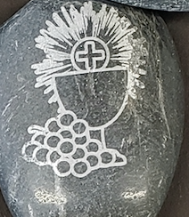

**Thank you for joining us today!**

if you would like to receive our weekly e-bulletin, please contact the church office (aschurch@allsaintschelmsford.org) To learn more about us, visit <https://www.allsaintschelmsford.org> or call us at 978 256 5673.